OPENAI 2026
IMPACT REPORT
INTELLIGENCE FOR EVERYONE
Responsible AI | Access and opportunity | People | Planet | Governance
OUR IMPACT THESIS
We believe broad access to advanced intelligence can expand human capability, accelerate discovery and create opportunity at a scale comparable to foundational public infrastructure.
Our responsibility is to make that benefit widely shared while managing the safety, environmental, workforce, community and governance impacts created by developing and deploying frontier AI at global scale.
Reporting period: Fiscal year 2025, with selected developments through 11 July 2026
DRAFT FOR INTERNAL REVIEW | PRE-ASSURANCE

REPORTING BASIS Forward-looking statements and pre-assurance information
REPORTING BASIS Pre-assurance information
Environmental figures and selected societal scenarios in this report are our internal estimates and are not yet externally assured. Forward-looking statements reflect our current plans and expectations and may change as technology, markets, policy, infrastructure and evidence evolve.

We report on our impact strategy, current performance, internal estimates and implementation plans across responsible AI, access, people, the environment, our value chain, communities and governance. Certain environmental, workforce and societal figures are pre-assurance estimates built from activity data, partner information and transparent assumptions. They have not yet been externally assured.
Our forward-looking statements, targets, planned programs and long-term scenarios are inherently uncertain and are not guarantees of future results. We will update boundaries, methods, estimates and prior-period information as metered, supplier-allocated and controlled enterprise data mature. We report enabled and avoided impacts separately from our corporate greenhouse-gas inventory and do not use them to offset our gross footprint.
CURRENT PERFORMANCE  Current programs, policies, scale or performance described in this report. | ESTIMATED  Internal pre-assurance estimate using stated assumptions and uncertainty ranges. | PLANNED  Program, control, target or disclosure included in our implementation roadmap. | DATA COLLECTION AND DISCLOSURE PLANS  Information being built for inclusion in future reports.

CONTENTS Report architecture
Section | Purpose
Leadership message | Our mission, responsibility and long-term impact thesis
2026 at a glance | Selected current indicators and pre-assurance environmental estimates
About us and our reporting approach | Scope, boundaries, materiality and reporting approach
1. Our impact strategy | Mission, theory of change, stakeholders, material topics and goals
2. Responsible AI and product stewardship | Safety, preparedness, privacy, security, child safety and product accountability
3. Access, opportunity and societal impact | Democratization, economic opportunity, education, health, science, jobs and 2050 scenarios
4. Our people | Culture, talent, inclusion, learning, well-being, employee voice and human-capital data
5. Climate and energy | Energy demand, Scope 1-3 estimate, efficiency, clean energy and carbon management
6. Water, materials and nature | Water stewardship, circularity, hardware, land, biodiversity and local environmental impacts
7. Responsible supply chain and communities | Human rights, contractor welfare, procurement, infrastructure and community benefit
8. Governance, ethics and accountability | Corporate structure, boards, risk, controls, transparency, policy and reporting governance
9. Climate risk, opportunities and resilience | TCFD / IFRS S2 analysis, scenarios, sensitivities and resilience actions
10. Performance data and methodology | Environmental and social metrics, estimation methods, limitations and assurance roadmap
11. Reporting indices | GRI, SASB, TCFD / IFRS S2, preliminary TNFD and UN SDG alignment
Appendices | Detailed assumptions, data collection and disclosure plans, controls and references

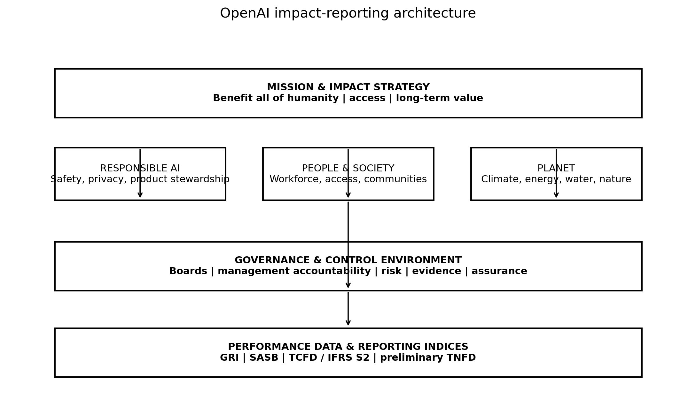
Figure 1. Our impact-reporting architecture
Our integrated architecture connects mission impact, responsible AI, people, environmental stewardship, value-chain responsibility, governance and long-term societal outcomes.

LEADERSHIP MESSAGE Building advanced intelligence for broad human benefit
OUR IMPACT THESIS Intelligence for everyone
We measure progress not only by how capable our systems become, but by whether those capabilities are broadly useful, responsibly governed, environmentally sustainable and translated into durable human benefit.

Our mission is to ensure that general-purpose artificial intelligence benefits all of humanity. By releasing ChatGPT directly to the public on 30 November 2022, we disrupted the traditional pattern in which the most capable technologies remained concentrated in laboratories and organizations able to pay for bespoke access. People everywhere gained a simple way to learn, write, code, analyze, create and solve problems with frontier AI. That direct public access helped establish a new expectation across our industry: advanced intelligence can be broadly usable and shareable rather than reserved for a narrow institutional elite. [1-4,56-58]
We believe this democratization of cognitive capability is a civilization-level contribution. More than 900 million people now use ChatGPT each week, and users who primarily communicate in languages other than English represent more than half of active users. Adoption has grown rapidly in lower-income and lower-HDI markets, expanding access to expertise for students, small businesses, creators, nonprofits and public-interest institutions. Access is not yet equal: cost, connectivity, language, disability, digital literacy, safety and local relevance still determine who benefits. We are working to close those gaps while improving capability and safety. [3,5,7]
Scale also creates substantial physical impacts. Our narrower workload lens estimates approximately 1.5 TWh of annual electricity use and about 0.72 MtCO2e, primarily associated with hosted compute in our value chain. Our expanded pre-assurance boundary, which adds a broader inference, training, research, capital-goods and other Scope 3 sensitivity, estimates approximately 4.0 TWh and 2.8 MtCO2e, with wide uncertainty ranges. These figures are not yet externally assured. They make clear that efficiency, additional clean power, responsible infrastructure, supplier decarbonization, water stewardship and transparent community engagement must advance at the same pace as our products.
The same technology that creates this near-term demand can also reduce the resource intensity of knowledge work and accelerate climate solutions. Our cognitive-substitution analysis shows that the incremental computational emissions for drafting code, research or visual concepts can be orders of magnitude below the time-allocated emissions of physical, human-only workflows. This is not an automatic offset. Human review, devices, model training, infrastructure, quality, job effects and rebound remain material. We therefore measure productivity, emissions intensity, absolute demand and distribution together rather than claiming a simple carbon dividend.
Our long-term strategy is to convert a period of visible infrastructure buildout into a durable conservation and human-development dividend. We are expanding efficient computing, evaluating large-scale firm clean-power pathways, strengthening grid and ratepayer protections, building product-level environmental accounting, and developing methods to measure AI-enabled mitigation without netting those outcomes against our inventory. Our 2050 scenarios test a future in which global access to intelligence supports higher productivity, shorter working time, faster scientific discovery and greater capacity for care, creativity and ecological stewardship. That future is not guaranteed. We intend to help build the energy, safety, labor, policy and governance conditions that make it possible.

2026 AT A GLANCE Selected scale, impact and environmental indicators
900M+  weekly active users  Current scale in 2026 [5] | 15B  API tokens per minute  Current 2026 run-rate [5] | >50%  of 10 GW Stargate goal planned  Our infrastructure update [33]
$25B  Foundation focus  Health and AI resilience plan [9] | 4.0 TWh  annual electricity  Central pre-assurance estimate | 2.8 MtCO2e  Scope 1-3  Central pre-assurance estimate

Metric | 2026 value | Status | Method / limitation
Public access | ChatGPT available through free and paid tiers across many markets | Current performance | Adoption and affordability data are growing; distributional outcome data remain limited.
Responsible AI | Preparedness Framework, system cards, Model Spec and external evaluations | Current performance | Safety metrics are spread across product releases rather than consolidated into one annual impact dataset.
Electricity | 4.0 TWh; range 1.9-9.5 | Estimated | Based on public traffic, token throughput and query-energy assumptions.
GHG emissions | 2.8 MtCO2e; range 0.7-9.6 | Estimated | Includes operating electricity and capital-goods sensitivity; organizational control is unknown.
Water | 3.8 billion liters | Estimated | Global proxy only; not suitable for basin-risk decisions.
Workforce demographics | Collection in progress | Data collection and disclosure plans | Future reports will include headcount, representation, retention, pay equity, safety and learning.
Supplier ESG performance | Collection in progress | Data collection and disclosure plans | Future reports will include supplier standards, assessments, corrective actions and purchased-goods emissions.
Assurance | Pre-assurance reporting | Data collection and disclosure plans | We plan phased limited assurance beginning with energy, GHG, water and selected access and safety metrics.

METHOD How to read our estimates
Our pre-assurance environmental values provide an initial enterprise baseline and a transparent bridge to primary measurement. Metered, supplier-allocated and controlled source-system data will progressively replace assumptions, and restatements will be reported when methods or boundaries materially change.

ABOUT US AND OUR REPORTING APPROACH Scope, reporting boundary and materiality
We report the impacts most closely connected to our mission, products, people, operations, infrastructure, value chain and role in society. Our reporting system is progressing from pre-assurance estimation toward controlled, comparable and externally assured enterprise data.

Our organization and mission
We are organized so that our Foundation controls OpenAI Group PBC. Our Foundation appoints and can replace Group directors, and the Safety and Security Committee remains a committee of the Foundation. This structure is intended to preserve mission control while enabling the capital formation required to build frontier AI infrastructure and products. [8-10]
Our mission - ensuring that general-purpose artificial intelligence benefits all of humanity - is the organizing principle for our impact reporting. We therefore define impact more broadly than environmental performance. Material topics include safety, access, privacy, economic opportunity, labor and human rights, energy and climate, water, community effects, governance and the long-term distribution of benefits and risks.

Reporting period and boundary
Dimension | Current reporting approach | Data collection and disclosure plan
Time | Fiscal year 2025, with notable developments through 11 July 2026 | We will maintain a stable annual cut-off, restatement policy and subsequent-events protocol.
Organizational boundary | Our corporate operations plus modeled compute allocated across controlled and supplier infrastructure | We are completing our legal-entity, asset, lease, cloud and operational-control inventory.
Value chain | Hardware, cloud/compute, construction, energy, business services, travel, commuting and downstream user devices considered where material | We are mapping spend and activity to all 15 GHG Protocol Scope 3 categories.
Geography | Global products and announced infrastructure, with U.S. and Norway examples | Future reports will include country- and site-level workforce, energy, water, community and incident data.
Social impacts | Users, workers, contractors, suppliers, communities, institutions and future generations | We are developing impact metrics disaggregated by geography, income, language, age, disability and user type.
Assurance | Pre-assurance; sources, methods and assumptions documented | We plan limited assurance of core metrics and controls, followed by reasonable assurance where feasible.

Reporting standards and frameworks
We align our reporting architecture with the GRI Universal Standards, the SASB standards for Software & IT Services and Internet Media & Services, the TCFD framework as incorporated into IFRS S2, the TNFD framework and the GHG Protocol. These frameworks support comparable reporting while our mission requires additional treatment of responsible AI, access, societal transition and long-term human benefit. [41-47]
- GRI: material impacts on people, the environment and the economy, including workforce, human rights, communities and governance.
- SASB: financially relevant industry metrics for energy, water, privacy, security, workforce and business continuity.
- TCFD / IFRS S2: governance, strategy, risk management, metrics, targets and scenario analysis for climate-related risks and opportunities.
- TNFD and GHG Protocol: location-specific nature dependencies and impacts, and consistent Scope 1, Scope 2 and Scope 3 accounting.

Materiality approach
We apply a double-materiality lens: the significance of our impacts on people and the planet, and the significance of sustainability-related risks and opportunities to our mission, strategy, resilience and financial performance. We are validating the assessment through structured engagement with users, employees, contractors, suppliers, communities, customers, civil society, researchers, policymakers and affected stakeholders.
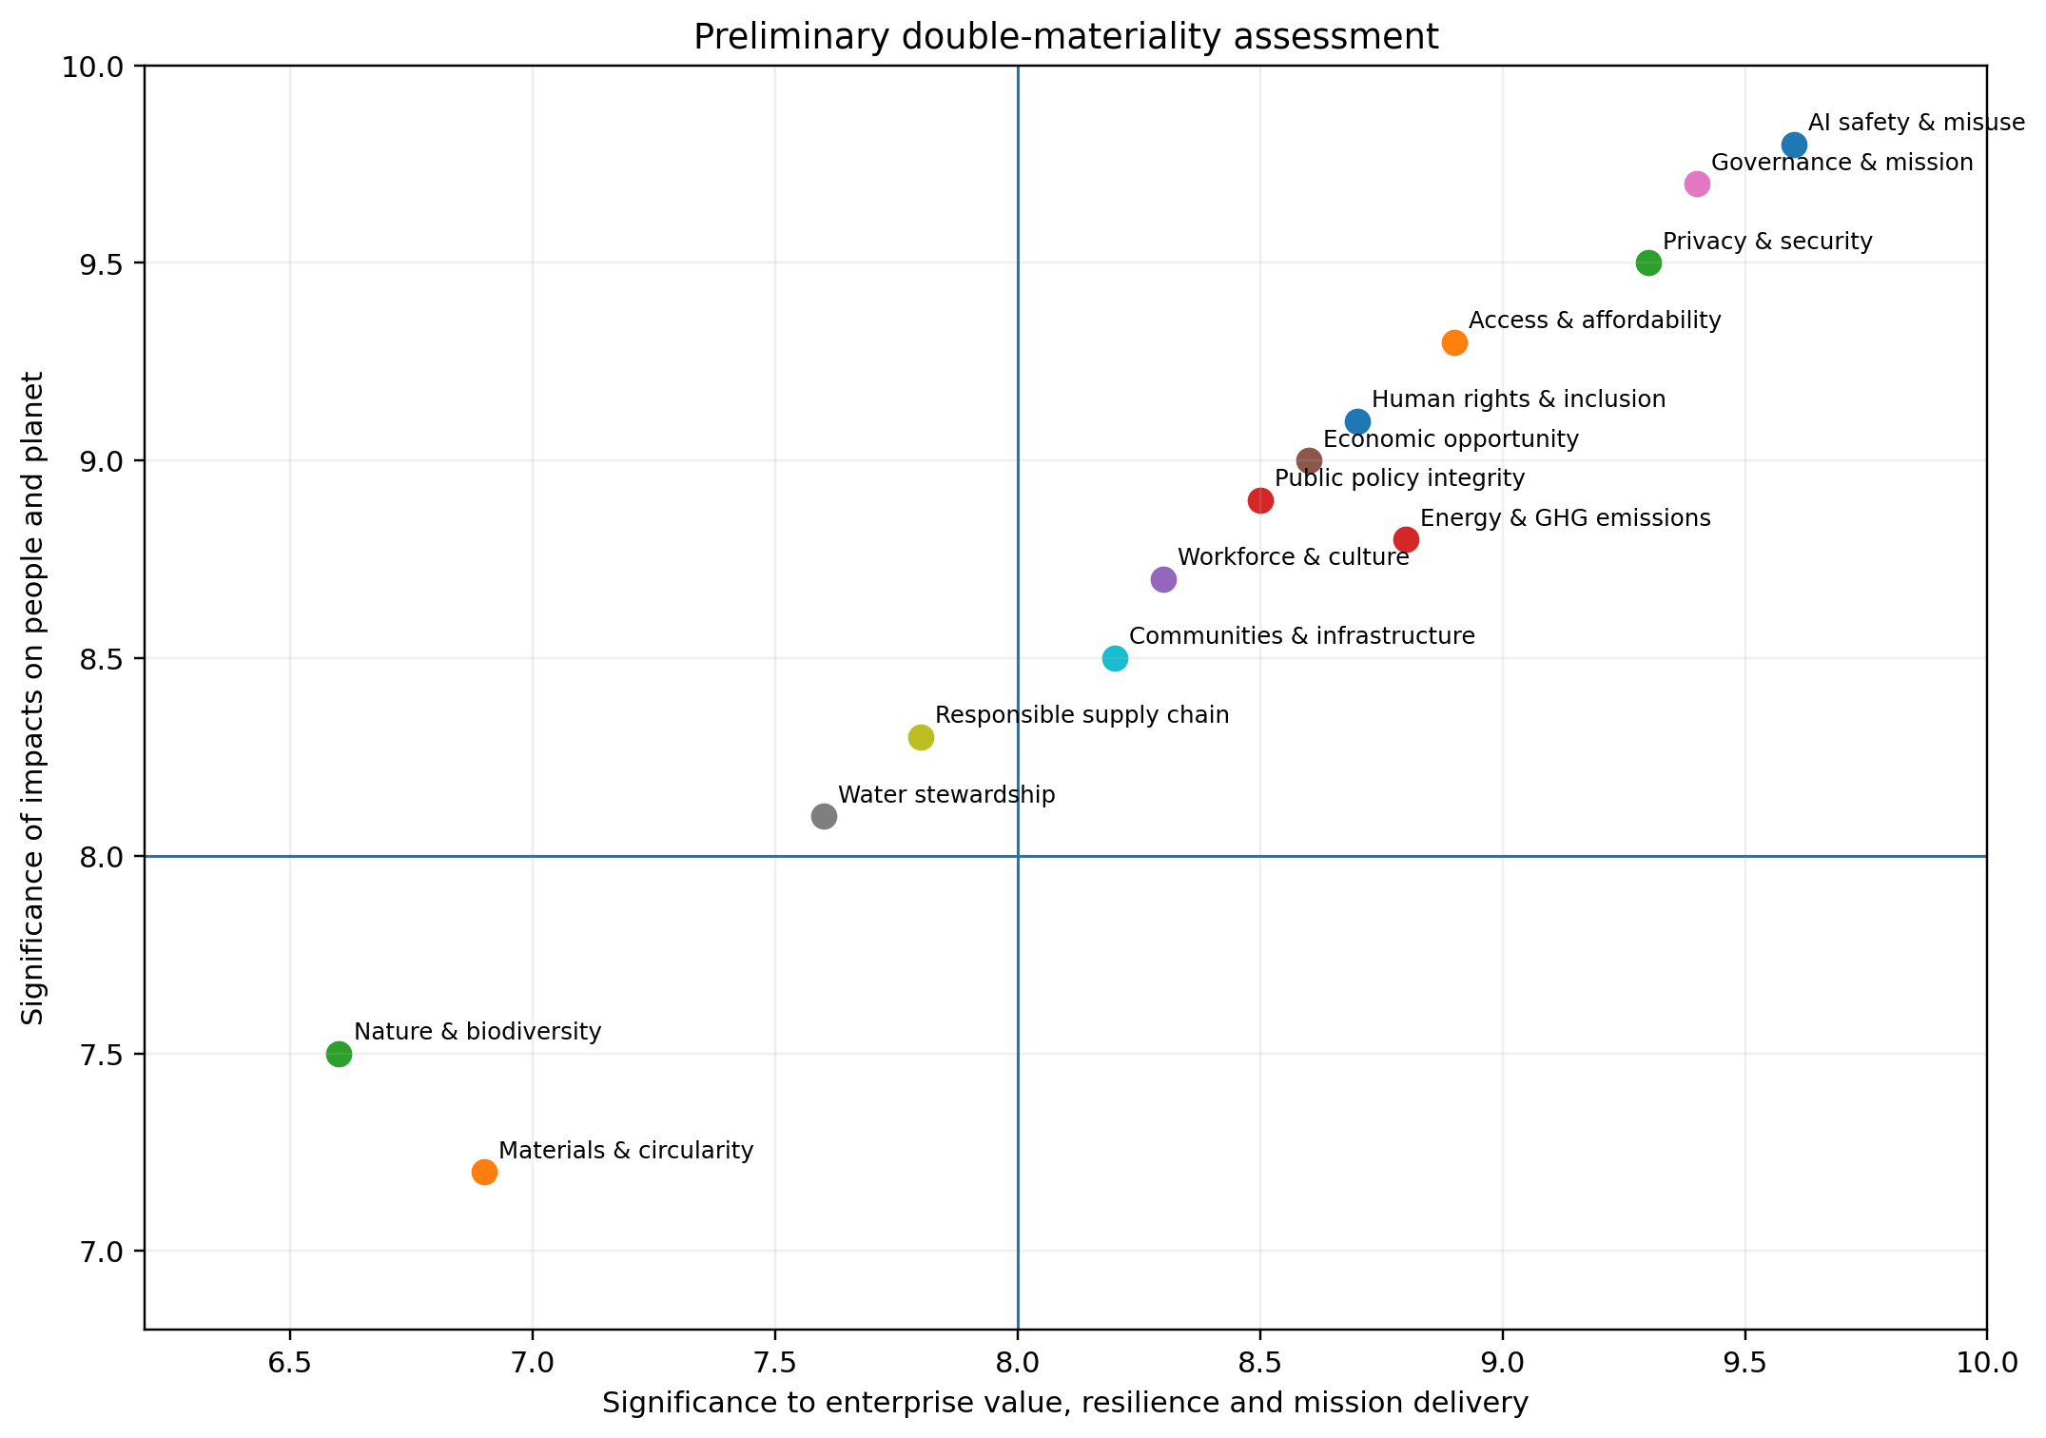
Figure 2. Double-materiality assessment
Current assessment; we plan periodic stakeholder validation and management review as our impacts, products and infrastructure evolve.

Stakeholders
Stakeholder group | Primary interests | Planned engagement and evidence
Users and the public | Utility, affordability, safety, privacy, accessibility, language coverage, recourse | User research, appeals data, surveys, accessibility testing, regional outcome studies.
Employees and contractors | Mission, pay and benefits, inclusion, learning, workload, voice, well-being, safety | Engagement survey, ethics channels, retention, pay equity, safety, learning and grievance data.
Communities near infrastructure | Power bills, jobs, water, air quality, land, tax base, emergency services | Community advisory panels, impact assessments, public dashboards, grievance and benefit agreements.
Suppliers and workers in the value chain | Clear standards, commercial feasibility, safe work, fair treatment, decarbonization support | Supplier code, risk segmentation, audits, worker voice, corrective action and carbon data.
Governments and regulators | Safety, competition, security, labor, consumer protection, environmental compliance | Transparent policy positions, regulatory reporting, incident cooperation, evidence-based consultation.
Researchers and civil society | Independent access, transparency, evaluation, systemic risk, distributional impacts | External testing, research grants, data access, public consultations, impact research and challenges.
Partners and customers | Reliability, security, data governance, compliance, environmental attributes, business value | Contractual controls, product documentation, audit evidence, allocated emissions and outcome metrics.

1 OUR IMPACT STRATEGY
Turning mission into measurable outcomes and accountable operating systems
Our impact strategy begins with a simple principle: capability, access and responsibility must advance together. We seek to expand the benefits of intelligence while reducing environmental burdens, managing foreseeable harms and strengthening the institutions needed for long-term public trust.

1.1 Mission and theory of change
Our theory of change has five connected pathways. First, we develop increasingly capable and useful AI systems. Second, we make those capabilities accessible through public products, developer platforms, partnerships and lower-cost options. Third, we build safety, security and governance into the model and product lifecycle. Fourth, we invest in infrastructure, people and institutions that allow benefits to scale. Fifth, we measure outcomes and adapt based on evidence, including evidence of unintended impacts.
Pathway | How value is created | Principal risks | Scenario outcome measures
Capability | Models help people reason, create, learn and solve problems | Misuse, overreliance, concentration, reliability failures | Task quality, scientific progress, user outcomes, safety evaluations.
Access | Free/low-cost products and APIs distribute advanced capabilities | Digital divide, language gaps, accessibility barriers, uneven adoption | Active users, cost per useful task, geographic/language reach, accessibility.
Responsible deployment | Testing, system cards, policies, monitoring and safeguards manage risk | Unknown capabilities, evasion, malicious use, weak recourse | Evaluation results, incident rates, enforcement consistency, remediation time.
Enabling systems | Compute, clean energy, talent, suppliers and communities support scale | GHG, water, land, labor, ratepayer and local impacts | Energy and water intensity, supplier performance, jobs, community outcomes.
Institutional learning | Research, transparency, stakeholder engagement and assurance improve accountability | Selective disclosure, weak controls, insufficient external challenge | Assured metrics, external evaluations, stakeholder actions, restatements.

1.2 Democratizing access as a cross-cutting impact
The public release of ChatGPT changed the diffusion pathway for frontier AI. Before November 2022, advanced language models were primarily accessed through research environments, limited demonstrations and enterprise or developer arrangements. By giving the public a simple conversational interface, we enabled students, small businesses, independent developers, creators, nonprofits and individuals to experience and apply frontier capabilities directly. [1-4]
We do not claim that every subsequent public AI release was caused by ChatGPT. The counterfactual cannot be observed. We do conclude that ChatGPT demonstrated mass demand and changed competitive expectations. Google launched Bard publicly in February 2023, Anthropic introduced Claude in March 2023 and Meta expanded access through the Llama family. Together, these developments shifted frontier-model access from a niche capability toward a public and developer ecosystem. [2,56-58]
IMPACT THESIS Civilization-level contribution
The durable contribution is not a single interface or model generation. It is the normalization of direct public access to advanced machine intelligence. That shift may ultimately matter as much as the technical improvement of the models themselves, because diffusion determines who can learn, experiment, innovate and participate.

1.3 Material topics
Topic | Impact significance | Enterprise significance | Why it matters
AI safety, security and misuse | Very high | Very high | Core product impact and mission risk.
Governance and mission integrity | Very high | Very high | Controls how capability and capital are directed.
Privacy, data governance and cybersecurity | Very high | Very high | Affects users, customers, regulators and trust.
Access, affordability and inclusion | Very high | High | Determines distribution of benefits.
Economic opportunity and workforce transition | Very high | High | Potentially large productivity, job-quality and inequality effects.
Energy and climate | High | High | Infrastructure scale creates significant demand and transition exposure.
Employees and culture | High | High | Scarce talent, high pace and ethical judgment are mission-critical.
Human rights and responsible supply chain | High | High | Hardware, construction, data work and content exposure create risks.
Communities and infrastructure | High | High | Local power, water, air, land and economic effects.
Water stewardship | High | Medium-high | Basin-specific scarcity and cooling/power dependencies.
Materials, circularity and nature | Medium-high | Medium | Embodied carbon, minerals, e-waste, land and biodiversity.

1.4 Goals and commitments
Our mission, safety, infrastructure and Foundation commitments provide the foundation for an integrated impact program. We are consolidating these commitments into a single goals architecture that connects responsible AI, access, people, climate, water, supply chain, communities and governance. The planned 2030 directions below will be converted into approved targets as baselines, owners, controls and assurance readiness are completed.
Impact area | Current position | Planned 2030 direction | 2027 reporting milestone
Mission benefit | Our mission and public-access strategy are established; we are consolidating outcome metrics | Publish a Mission Impact Framework with distributional outcomes by geography and user group | Define metric owners, baselines and external review for access, safety and societal outcomes.
Responsible AI | Our Preparedness Framework, system cards, Model Spec, policies and testing are in operation | Publish annual consolidated safety and responsible-product metrics with consistent definitions | Release a first cross-product metric dictionary and incident taxonomy.
Climate | Our enterprise GHG baseline is in pre-assurance development | Set science-informed Scope 1-3 targets after completing a controlled baseline | Publish assured Scope 1-3 inventory, boundary memorandum and transition plan.
Energy | Our infrastructure principles include paying for generation and grid upgrades | Match growth with additional clean, reliable power and disclose hourly and site performance | Disclose facility energy, PUE, contractual instruments and marginal impacts.
Water | We have announced closed-loop or low-water design for selected sites | Adopt basin-informed water targets and replenishment for high-stress locations | Publish site withdrawal, consumption, WUE and basin-risk screening.
Supply chain | We are consolidating partner and project requirements into an enterprise program | Implement a supplier code, human-rights due diligence and supplier decarbonization program | Risk-map strategic suppliers and disclose audit/corrective-action metrics.
People | We maintain equal-opportunity commitments and a mission-led culture; quantitative reporting is being built | Publish representation, pay equity, retention, learning, engagement and safety outcomes | Establish controlled human-capital dataset and employee-impact governance.
Assurance | Our reporting is pre-assurance | Obtain limited assurance over core environmental, access and safety metrics | Complete readiness assessment and remediate priority controls.

1.5 Accountability and operating cadence
We manage impact reporting as an enterprise operating system rather than an annual writing exercise. Topic owners maintain definitions, source systems, evidence and controls throughout the year. A cross-functional Impact Reporting Council resolves ownership and methodology issues; an executive steering committee reviews performance and risk quarterly; and the board or relevant Foundation committee reviews material conclusions and approves our annual disclosures.
Forum | Cadence | Core participants | Decision rights / outputs
Topic working groups | Monthly | Product, Safety, People, Finance, Legal, Infrastructure, Procurement, Global Affairs, Communications | Data quality, milestones, evidence, remediation and narrative development.
Impact Reporting Council | Monthly / biweekly in reporting season | Reporting lead plus functional data and policy owners | Definitions, scope, controls, disputed claims, dependencies and escalations.
Executive steering committee | Quarterly | Senior functional leaders and executive sponsor | Performance, risk appetite, resources, commitments and disclosure judgments.
Board / Foundation oversight | At least semiannual | Relevant board or committee members | Mission alignment, material risks, major targets and report approval.
External challenge | Annual and topic-specific | Assurance provider, experts, civil society, affected stakeholders | Assurance findings, methodology review and stakeholder feedback.

2 RESPONSIBLE AI AND PRODUCT STEWARDSHIP
Developing and deploying systems that are useful, safe, secure and accountable
Responsible AI is the foundation of our social impact. We seek to identify risk before deployment, communicate system limitations, monitor real-world use, provide meaningful recourse and improve safeguards as capabilities and contexts evolve.

2.1 Safety across the lifecycle
Our public safety approach combines model development practices, capability evaluations, red teaming, the Preparedness Framework, deployment safeguards, system cards, usage policies, monitoring and iterative updates. We have described this lifecycle as teaching models, testing them and sharing evidence about how they behave. [13-18]
Lifecycle stage | Principal controls | Reportable metrics
Research and training | Data governance, security, alignment research, capability testing, access controls | High-risk research reviews; training incidents; security findings; mitigations completed.
Pre-deployment evaluation | Internal and external red teaming, preparedness evaluations, system-card review | Evaluation coverage; high-severity findings; residual-risk decisions; external evaluator participation.
Launch decision | Cross-functional safety, legal, policy and product review; staged access where appropriate | Launch conditions; risk acceptances; unresolved findings; executive and committee approvals.
Deployment safeguards | Policy enforcement, classifiers, monitoring, rate limits, identity or access controls where appropriate | Detection precision/recall; enforcement volume; appeals; false-positive rates; evasion trends.
Post-deployment learning | Incident response, user reports, model updates, policy revisions and research | Incident frequency/severity; time to detect/contain/remediate; repeat events; lessons implemented.

2.2 Preparedness for frontier risks
Our Preparedness Framework is designed to track and prepare for severe harm from increasingly capable models. It supports structured evaluation and governance for risks that may emerge as capabilities improve. We plan comparable annual reporting on evaluation domains, governance, deployment conditions, external testing and how findings changed a model or product decision, subject to legitimate security constraints. [14-16]
PLANNED Annual safety dashboard
We plan a consolidated dashboard covering evaluation coverage, high-severity findings, external assessment, incidents, enforcement and appeals, security events, child-safety interventions, privacy events and corrective-action completion. Stable definitions will support year-over-year comparison while protecting information that could enable misuse.

2.3 Model behavior and transparency
We publish the Model Spec to explain intended model behavior and system cards to document capabilities, limitations, evaluations and mitigations for individual releases. We plan an annual cross-product summary of material changes to model behavior policies, known limitations, evaluation methods and areas where evidence remains uncertain. [17-19]

2.4 Usage policies, moderation and appeals
Our usage policies describe prohibited and restricted uses. Product enforcement may include automated and human review, warnings, restrictions, suspensions or termination, and we provide avenues for appeal. Future reports will describe policy application, the distribution and severity of enforcement actions, appeal outcomes, significant policy changes and protections for reviewers and contractors who may encounter harmful content. [20-22]
Disclosure area | Current public evidence | Future KPI set
Policy clarity | Usage policies and transparency materials are public | Policy-change log; user comprehension; regional availability; notice quality.
Enforcement | Processes and selected reports are public | Actions by reason/severity; automation vs. human review; false positive/negative measures.
Appeals and recourse | Appeal channels are described | Appeal volume, resolution time, overturn rate, accessibility and systemic fixes.
Reviewer well-being | We are building a consolidated annual metric set | Exposure controls, training, counseling, rotation, injuries/illness and worker feedback.

2.5 Child and teen safety
Children and teenagers require age-appropriate design, stronger safeguards, privacy protection, parental tools and careful handling of sensitive situations. We have published child-safety and well-being information and continue to develop parental controls and expert networks. We are consolidating these initiatives into a child-rights and youth-safety framework aligned to product design, testing, incident response and reporting. [23-26]
- Age-appropriate risk and impact assessments before material product changes.
- Testing for grooming, exploitation, self-harm, age-inappropriate content, manipulation and privacy harms.
- Accessible parental and guardian controls without displacing the rights and agency of young people.
- Escalation protocols with qualified clinicians and child-safety experts where appropriate.
- Transparent reporting on high-severity events, safeguards, response times and corrective actions.

2.6 Privacy, data governance and security
Business data are not used to train our models by default. We maintain encryption, security controls and certifications including SOC 2 Type 2 and ISO standards. Privacy and security are essential to user trust and enterprise adoption. We plan annual reporting on governance, incidents, data-subject requests, retention choices, product-control adoption, security testing, supplier security and significant corrective actions, while avoiding disclosures that create new vulnerabilities. [27-29]
Topic | Our approach | Planned annual disclosure
Data use and training | Product-specific controls and contractual protections; business data not used for training by default | Data-control adoption, opt-out/temporary-chat use, exceptions, retention and audit results.
Cybersecurity | Enterprise controls, testing, certifications and incident response | Material incidents, significant vulnerabilities, time to remediate, third-party risk coverage.
Privacy rights | Notices and user rights by applicable jurisdiction | Requests, response times, complaints, substantiated breaches and corrective actions.
Government requests | Transparency reporting on requests where permitted | Request volumes, legal basis, response rates, challenged requests and affected accounts.
AI data governance | Dataset, model and evaluation governance | Documented lineage, sensitive-data controls, high-risk dataset review and deletion/rectification processes.

2.7 Fairness, accessibility and inclusion
Broad access is meaningful only when systems work across languages, cultures, abilities and socioeconomic contexts. We are building evaluations for differences in quality, refusal behavior, harmful stereotyping, accessibility and cost, with transparent limits where measurement is constrained. Participatory research and recourse complement distributional testing.
DATA COLLECTION AND DISCLOSURE PLANS Access and distributional outcomes
We are consolidating accessibility, language, distributional-quality, user-recourse and outcome data for future mission-impact reporting.

3 ACCESS, OPPORTUNITY AND SOCIETAL IMPACT
Expanding human capability while managing transition and distribution
The largest potential benefit of AI lies beyond our own operations. We examine whether people can access useful intelligence, whether it improves outcomes, whether benefits are fairly distributed and whether institutions can manage the resulting economic and social transition.

3.1 Public access and diffusion
By 2026, we served more than 900 million weekly active users across geographies. Our research on ChatGPT usage shows broadening adoption across work and non-work activities, while newer adoption data show that users who primarily communicate in languages other than English now represent more than half of active users and that relative growth has been especially rapid in lower-HDI markets. [3,5-7]
User scale is not, by itself, proof of benefit. We measure the quality, affordability and outcomes of access: cost per useful task; language and accessibility coverage; adoption among lower-income users, small organizations and public-interest institutions; learning and productivity outcomes; and barriers including connectivity, payment access, devices and digital literacy.

3.2 Counterfactual: a world without a public ChatGPT launch
To understand the significance of public access, we compare two stylized scenarios. The counterfactual is not a claim about what any specific company certainly would have done. It is an analytical scenario in which we did not release ChatGPT publicly in November 2022 and frontier models remained primarily available to large enterprises, cloud customers and research partners for a longer period.
Dimension | Closed-frontier counterfactual | Observed mass-access pathway
Primary users | Large enterprises, laboratories, governments and well-funded developers | Individuals, students, small businesses, nonprofits and enterprises.
Interface and discoverability | Specialized APIs, bespoke products and limited demonstrations | Simple conversational product with free access and rapid word-of-mouth adoption.
Market signal | Uncertain mass demand; emphasis on enterprise monetization | Visible global demand; competitors accelerate public assistants, APIs and open-weight offerings.
Innovation distribution | Concentrated in organizations with compute, capital and technical staff | Distributed experimentation by millions of users and developers.
Skills and learning | Institutional training; slower informal learning | Immediate experiential learning, AI literacy and user-led discovery.
Risks | Lower initial exposure but concentrated power and slower public preparedness | Faster diffusion of benefits and harms; higher urgency for safety, policy and education.
Access scale | Approximately 100 million enterprise seats in the scenario | More than 900 million weekly active users in 2026
Annual time-saving envelope | Approximately 11.4 billion hours at 2.2 hours per week | Approximately 103 billion hours at 2.2 hours per week

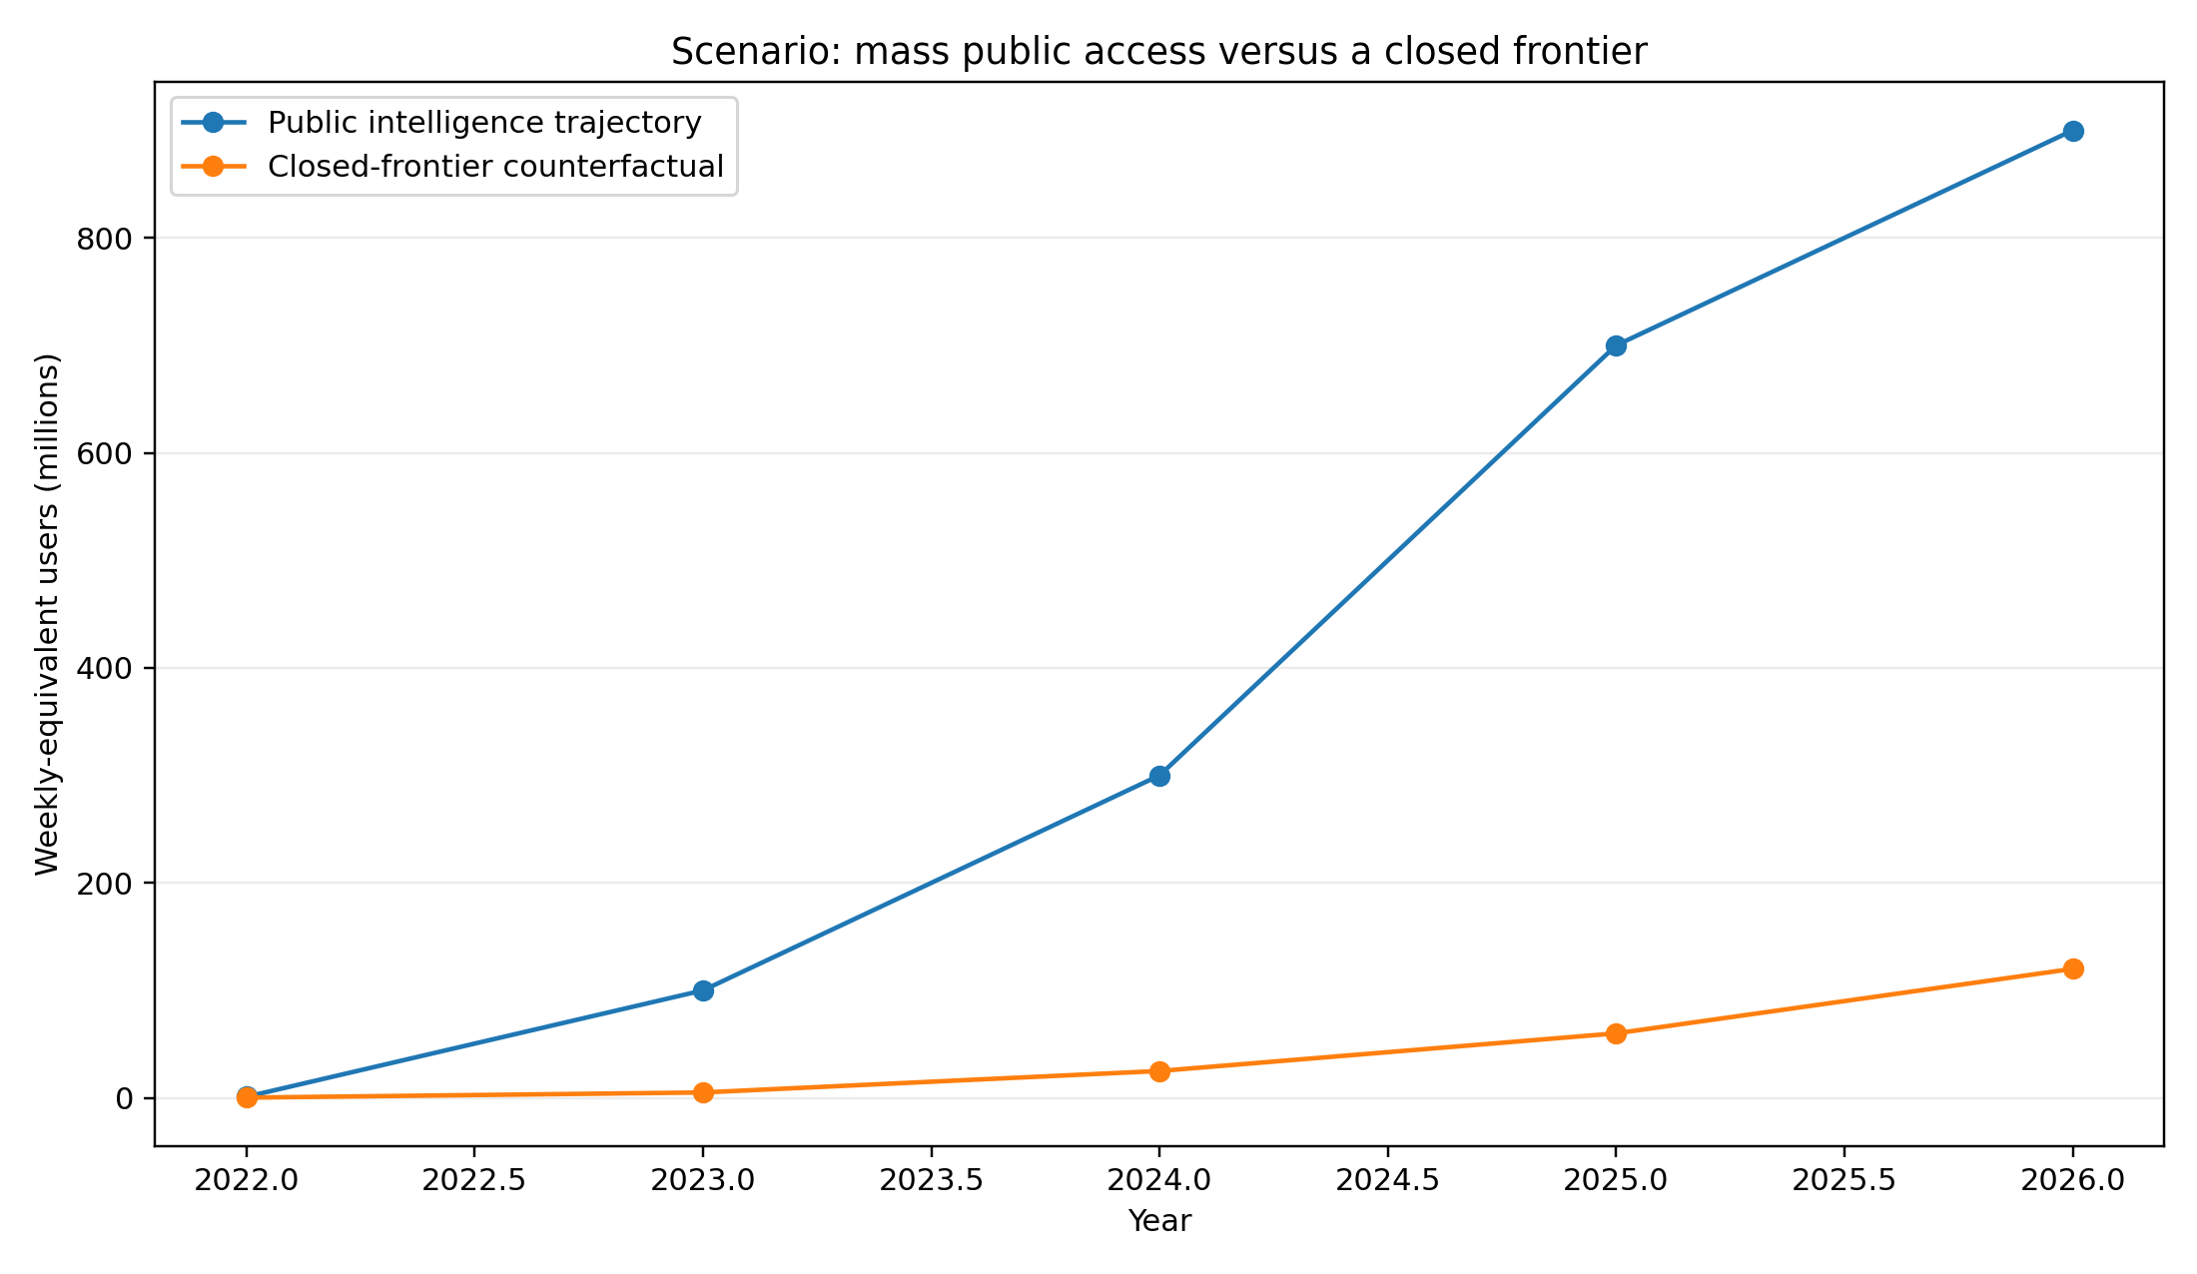
Figure 3. Frontier-AI access scenarios
Scenario analysis, not a causal estimate. The observed pathway reflects our public launch and subsequent industry diffusion.
The central conclusion is not that every competitor would have withheld access indefinitely. It is that our public launch materially shortened the time between frontier research and mass use, demonstrated global demand and brought questions about safety, employment, education and governance into public view earlier than an enterprise-only pathway likely would have done.

3.3 Economic opportunity and productivity
Published research has found substantial productivity gains in some customer-support, writing and coding tasks, particularly for less experienced workers, while other studies show heterogeneous or negative effects when tools are poorly matched to complex work. We therefore report productivity as a portfolio of task-specific outcomes, not a universal percentage. [37-40]
Evidence | Finding | Implication for impact reporting
Generative AI at Work | Average productivity increased about 14% in a customer-support setting, with larger gains for lower-skill/less-experienced workers | Measure who gains, quality, learning and job design, not just aggregate output.
Noy and Zhang | Professionals completed selected writing tasks faster with higher quality | Track time, quality and downstream use; avoid extrapolating to all knowledge work.
GitHub Copilot experiment | Participants completed a defined coding task materially faster | Measure accepted/maintainable code and defects, not raw code volume.
METR developer study | Experienced open-source developers were slower in the studied setting despite expecting gains | Include adverse or null results and task-context boundaries.

3.4 Cognitive substitution and the future of work
By making advanced AI directly accessible, we created a new form of cognitive infrastructure: centralized computation that can augment drafting, coding, analysis, design and administrative work at very low incremental emissions per task. We call this mechanism cognitive substitution. It can decouple part of economic and intellectual production from commuting, travel, office occupancy, physical prototyping and repetitive labor, but only when organizations translate time savings into real changes in resource use.

Widespread access and cognitive augmentation
More than 900 million people now use ChatGPT each week. Applying the 2.2 hours per week reported by generative-AI users in a Federal Reserve Bank of St. Louis study to the full user base produces an upper-bound access envelope of approximately 103 billion hours a year. A stylized gated world with 100 million enterprise seats produces roughly 11.4 billion hours under the same assumption. The difference - approximately 91.5 billion hours, or $1.37 trillion at a uniform $15 per hour - is not measured GDP or realized value: many uses are non-work, time savings vary, and displacement and rebound must be considered. It illustrates the scale of opportunity created when frontier intelligence is public rather than institutionally enclosed. [5,69]

Carbon-intensity decoupling
Our central workplace model allocates approximately 1.93 tCO2e per worker-year, or about 1.0 kgCO2e per work-hour. A higher-bound scenario using broader office and commuting assumptions reaches approximately 4.9-5.8 tCO2e, or about 2.5 kgCO2e per work-hour. Producing 100 accepted lines of code over 32 hours therefore carries approximately 31-80 kgCO2e of time-allocated workplace emissions. Generating a comparable first draft with an assumed 5 Wh model workload emits about 2.4 gCO2e on a standard grid. On this narrow incremental-compute comparison, emissions intensity is roughly 13,000-33,000 times lower. The comparison does not eliminate human review, device use, the software lifecycle or our infrastructure footprint; it shows why productivity gains can sharply reduce emissions per unit of useful output.
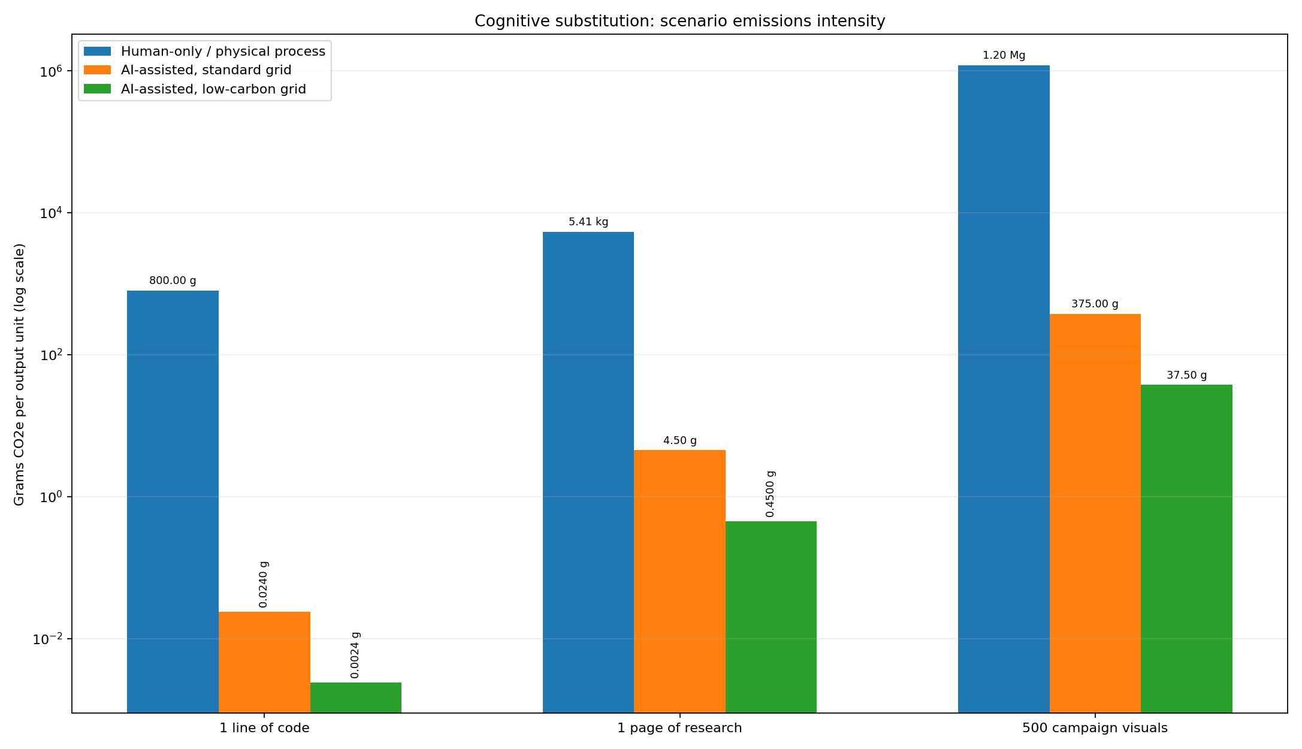
Figure 4. Cognitive substitution: scenario emissions intensity of selected outputs
Logarithmic scale. Human-only values allocate workplace emissions to task time; AI values represent incremental inference electricity under stated assumptions. See Section 10.4.
Productivity unit | Human-only allocation | AI-assisted - standard grid | AI-assisted - low-carbon grid | Intensity reduction
1 line of code | 0.31-0.80 kgCO2e | 0.024 gCO2e | 0.0024 gCO2e | >99.99%
100 lines of code | 31-80 kgCO2e | 2.40 gCO2e | 0.240 gCO2e | >99.99%
1 page of research | 5.41 kgCO2e | 4.50 gCO2e | 0.450 gCO2e | 99.92%
500 campaign visuals | 1,200 kgCO2e | 0.375 kgCO2e | 0.0375 kgCO2e | 99.97%
The comparison spans several orders of magnitude because centralized digital computation can produce an additional draft or concept with little incremental energy relative to the time and physical infrastructure allocated to a conventional workflow. These are scenario values, not product carbon footprints. They exclude review, devices, model training, capital goods and rebound, all of which remain in our corporate and value-chain accounting.

Creative work and physical-process substitution
Physical production can create stronger substitution opportunities. A conventional location photography campaign can require passenger travel, equipment freight, temporary sets and local power. In a scenario with 1.2 tCO2e for the shoot, 500 visual concepts generated with our image models at 1.5 Wh each produce about 0.375 kgCO2e on a standard grid - a 99.97% reduction in the concept-generation stage. Human creative direction, licensing, final production, cultural quality and downstream media remain within the decision boundary.

Project compression and lifestyle carbon
When a team completes a project in four weeks instead of six, environmental savings occur only if building schedules, travel, procurement, equipment use or working time also change. We are developing case-study methods that measure actual avoided trips, occupied floor area, materials, energy and time rather than treating productivity as an automatic offset. The same discipline applies to remote collaboration, automated administration, digital prototyping and faster research cycles.

Rebound and the Jevons paradox
Lower emissions per task do not guarantee lower absolute emissions. Cheaper and faster cognitive production can expand the total volume of software, research, images and automated activity. We treat this rebound effect as a material transition risk. Our response combines lower energy per token and per successful task, efficient routing and hardware utilization, greater clean-energy coverage, absolute electricity and water reporting, and product design that directs intelligence toward high-value outcomes rather than unnecessary computation.

Productivity, leisure and distribution
We pair productivity measurement with job quality, worker agency, compensation and leisure. Our long-term scenarios test whether societies capture part of the productivity dividend as shorter working time, care, learning, community participation and ecological stewardship rather than only as higher output. These outcomes depend on labor institutions, education, competition and mechanisms that distribute gains. We plan longitudinal research and partnerships to measure them.

3.5 Jobs, skills and worker transition
AI changes tasks before it necessarily changes occupations. Our role is to help workers, employers, educators and governments understand task exposure, redesign work, build skills and ensure that productivity gains improve job quality and opportunity. We have published jobs-transition and workforce resources and support AI literacy through OpenAI Academy. [30-32]
- Publish task-level evidence on adoption, productivity, quality, wage and employment outcomes.
- Expand accessible, multilingual AI literacy and role-specific learning pathways.
- Support credentials and evidence of practical competence rather than access to tools alone.
- Partner with employers and worker organizations on responsible deployment and work design.
- Measure whether gains accrue to workers through wages, reduced workload, advancement or increased leisure - not solely to output and capital returns.

3.6 Education, science and health
AI can expand tutoring, feedback, translation, scientific reasoning, data analysis and access to expertise. It can also enable cheating, propagate errors, reduce critical thinking or create unsafe health advice. We are developing outcome evaluation by domain and user group, including learning gains, teacher workload, scientific validity, accessibility and safety. Our Foundation has identified health and AI resilience as priority areas, creating an opportunity to connect grants to measurable public outcomes. [9,34-36]
Domain | Potential benefit | Material risk | Planned outcome evidence
Education | Personalized explanations, feedback, translation and teacher support | Overreliance, inequity, assessment integrity, privacy, inaccurate content | Learning gains, teacher time, access, error rates, safeguarding and long-term retention.
Science | Literature synthesis, coding, hypothesis generation and experimental support | Fabricated evidence, reproducibility, concentration of capability, dual use | Validated discoveries, time to result, reproducibility, open-science access and risk controls.
Health | Navigation, documentation, research and patient/clinician support | Unsafe advice, bias, privacy, regulatory and liability risks | Clinical validation, escalation, disparities, time saved, errors and patient outcomes.
Public services | Translation, case support, analysis and citizen access | Due-process failures, surveillance, exclusion and automation bias | Service quality, access, appeals, human oversight and distributional outcomes.

3.7 Foundation, nonprofits and communities
Our Foundation is focusing substantial resources on health and AI resilience and has supported people-first and nonprofit initiatives. Future reports will include grant strategy, selection, conflicts, geographic and beneficiary distribution, additionality, outcomes and independent evaluation. We report Foundation impact separately from corporate operational performance while showing how both advance our mission. [9-12]

3.8 2050 scenarios: toward a global intelligence dividend
We developed four 2050 scenarios to test how AI access, productivity, working time and system emissions could interact. The positive scenarios require more than technical capability: low-cost access, broad digital infrastructure, education, worker bargaining power, efficient models, clean electricity, resilient grids and policies that allow productivity to translate into time and welfare.

Transformative access pathway to 2050
The pathway below is a transformative scenario rather than a forecast. It assumes continued expansion of affordable access and a growing share of time savings captured as leisure and higher-value human activity. It does not assume that access alone guarantees productivity, well-being or equitable distribution.
Year | People with public access |  | Hours saved / user / week |  | Total hours freed / year |  | Scenario milestone
2026 | 0.9 billion |  | 2.2 hours |  | Approximately 103 billion |  | Mass public adoption and early workflow integration
2030 | 2.5 billion |  | 4.0 hours |  | Approximately 520 billion |  | Broad multilingual access and institutional adoption
2040 | 5.0 billion |  | 6.0 hours |  | Approximately 1.56 trillion |  | Deep integration with education, work and public services
2050 | 6.5 billion |  | 8.0 hours |  | Approximately 2.70 trillion |  | Global cognitive abundance with substantial leisure capture
Scenario | AI-active workers | Productivity uplift |  | Leisure capture |  | Days of leisure / worker |  | Net climate effect
Constrained diffusion | 3.0bn | 8% |  | 10% |  | 1.6 |  | -46 to -11 MtCO2e/yr
Managed abundance | 3.6bn | 18% |  | 30% |  | 10.0 |  | 26 to 41 MtCO2e/yr
Universal intelligence dividend | 4.1bn | 30% |  | 50% |  | 25.2 |  | 164 to 184 MtCO2e/yr
Rebound-intensive downside | 4.1bn | 25% |  | 5% |  | 2.2 |  | -143 to -43 MtCO2e/yr

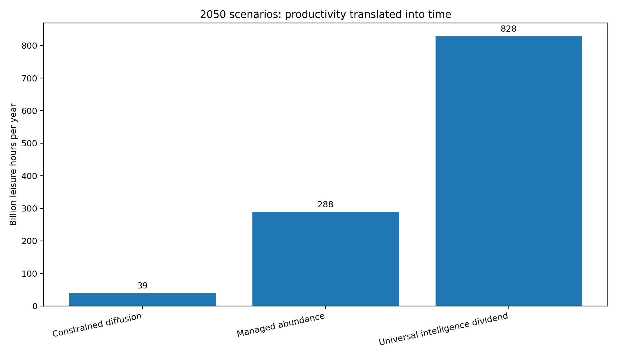
Scenario values extend the 2.2-hour weekly user estimate into progressively more capable and widely accessible systems. They are not forecasts of adoption, employment or welfare.
Figure 5. Scenario annual leisure-time dividend in 2050
Scenario output depends on productivity, workforce participation and the share of gains converted into reduced working time.
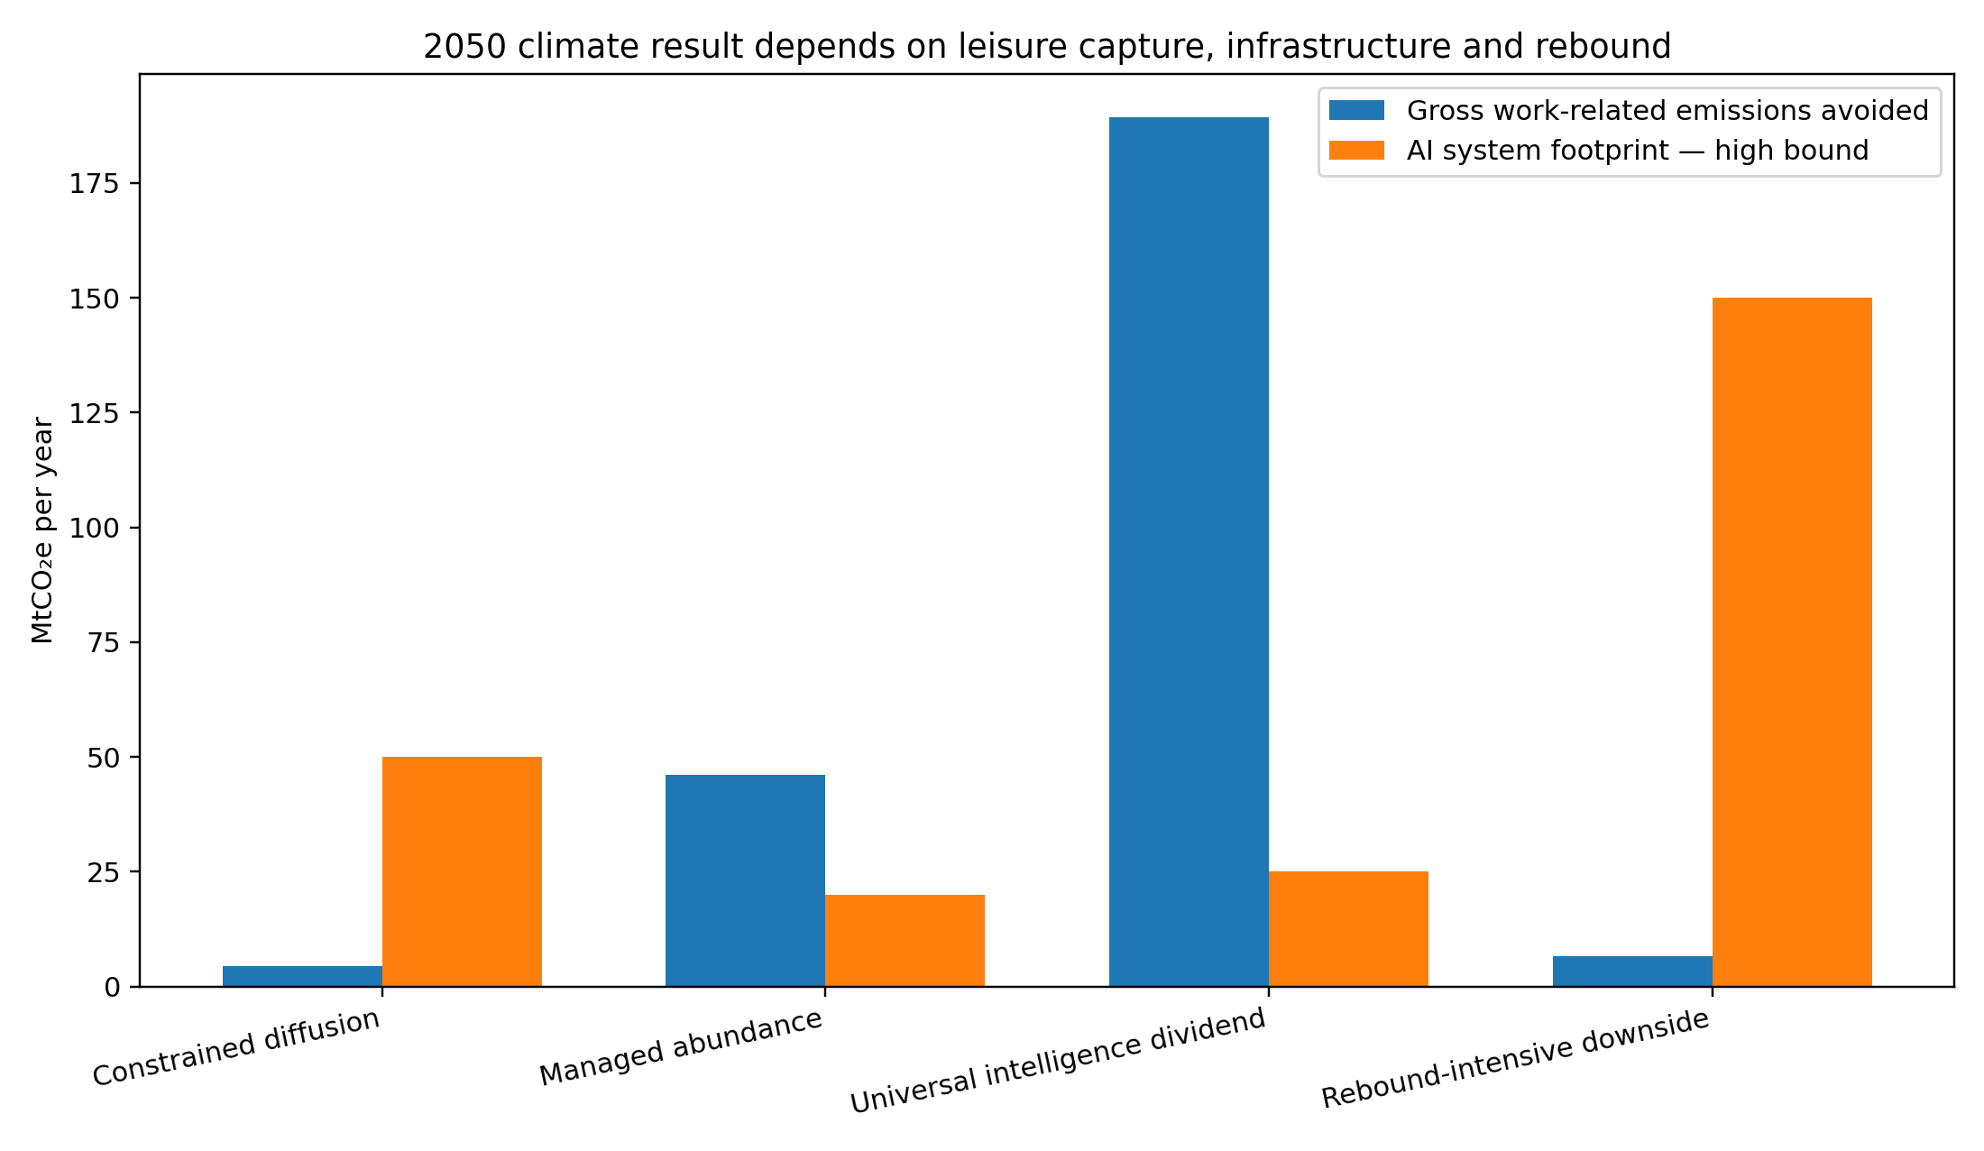
Figure 6. Scenario net climate effect of 2050 AI scenarios
Positive values indicate modeled net reductions after AI-system emissions; results are highly sensitive to rebound and power-sector decarbonization.
Under the universal-intelligence-dividend scenario, AI-active workers gain roughly 25 additional eight-hour days of leisure while work-related resource demand falls and AI systems run more efficiently and cleanly. Rebound-intensive downside produces the opposite result. We therefore measure success not only by tokens, users, revenue or benchmarks, but by whether people gain agency, opportunity, health, learning and time within environmental and social limits.

4 OUR PEOPLE
Building a mission-driven, inclusive, healthy and accountable organization
Our people make high-consequence judgments under rapid technological and organizational change. Sustaining our mission therefore depends on talent, inclusion, ethical culture, learning, employee voice, health, safety and the ability to retain people without normalizing unsustainable work practices.

4.1 Culture and values
We cultivate a culture centered on mission, intense learning, collaboration and responsibility. We are building a workforce measurement system covering employee experience, ethical climate, psychological safety, confidence in leadership, ability to raise concerns, workload and understanding of the mission. Future reports will connect these measures to retention, well-being and organizational effectiveness. [59]
Culture dimension | Why it matters | Planned measure
Mission connection | Supports judgment and retention in a high-ambiguity environment | Share of employees who understand and believe their work advances the mission.
Psychological safety | Employees must be able to challenge assumptions and escalate risk | Survey index; speak-up confidence; retaliation allegations; resolution outcomes.
Responsible pace | Chronic overload can impair safety, health and decision quality | Workload index; hours; leave use; burnout risk; critical-team staffing.
Cross-functional trust | Safety, legal, product and infrastructure decisions require cooperation | Decision-cycle quality; escalation effectiveness; collaboration survey.
Learning culture | Capability and risk evolve rapidly | Learning hours; participation; internal mobility; post-incident learning completion.

4.2 Talent, development and retention
Frontier AI depends on highly specialized technical talent as well as policy, safety, security, legal, operations, infrastructure, finance and communications expertise. We plan to report employee headcount, hiring, voluntary and involuntary turnover, critical-role retention, internal mobility, learning investment and succession coverage, including how contingent workers and contractors are governed within our workforce boundary.
- Role-based onboarding on mission, safety, privacy, security, human rights and environmental responsibilities.
- Continuous technical and leadership development for managers operating across research and product functions.
- Succession planning for high-dependency roles and governance positions.
- Career pathways that allow experts to advance without moving into people management.
- Responsible use of AI in hiring, performance and workforce decisions, with human oversight and validation.

4.3 Equal opportunity, inclusion and pay equity
We are an equal-opportunity employer. We are building controlled data on representation by level and function, hiring and promotion, retention, pay equity, accessibility and inclusion. We will use appropriate aggregation to protect privacy while allowing stakeholders to assess progress. [60]
DATA COLLECTION AND DISCLOSURE PLANS Workforce performance
We are consolidating headcount, demographics, pay equity, turnover, promotion, engagement, learning, occupational health and safety, and employee-voice data into a controlled global dataset. Future reports will provide comparable results with appropriate privacy safeguards.

4.4 Health, safety and well-being
Our occupational health and safety boundary includes offices, laboratories, travel, events, on-site technical work and relevant contractors. It also includes psychosocial risks arising from workload, security threats and exposure to harmful content. We govern construction and data-center safety through the same enterprise framework, with contractor and supplier responsibilities addressed in our value-chain program.
Risk area | Examples | Core controls and metrics
Office and ergonomic safety | Repetitive strain, indoor environment, emergency response | Ergonomic assessments, training, incidents, lost time, emergency exercises.
Psychosocial health | Workload, uncertainty, public scrutiny, harassment, security concerns | Workload controls, manager training, counseling, leave, survey and case outcomes.
Content exposure | Review of violent, abusive, sexual or self-harm content | Exposure minimization, rotation, qualified support, contractor parity, health outcomes.
Travel and field activity | Security, transport, remote work and event risks | Travel risk management, incident reporting and emergency support.
Contractor and construction safety | High-risk work at infrastructure sites | Prequalification, induction, leading indicators, serious incidents and corrective actions.

4.5 Employee voice and ethics
Employees have multiple confidential channels to raise safety, legal, ethical, people and environmental concerns. Future reports will include channel availability, substantiated matters, time to resolution, themes, corrective actions and anti-retaliation controls. High-severity product or mission concerns have clear escalation paths independent of the originating management chain.

4.6 Planned workforce performance table
Metric | 2026 status | Status | Method / limitation
Total employees | Collection in progress | Data collection and disclosure plans | Disclose average and year-end headcount by geography, function and employment type.
Representation by level | Collection in progress | Data collection and disclosure plans | Gender and relevant regional race/ethnicity measures, with privacy protections.
Adjusted pay equity | Collection in progress | Data collection and disclosure plans | Report methodology, residual gaps and remediation.
Voluntary turnover | Collection in progress | Data collection and disclosure plans | Disclose overall and critical-role turnover.
Learning hours | Collection in progress | Data collection and disclosure plans | Include safety, privacy, management and technical learning.
Employee engagement | Collection in progress | Data collection and disclosure plans | Report response rate and key indices, including speak-up and workload.
Recordable injuries / serious incidents | Collection in progress | Data collection and disclosure plans | Include employee and contractor boundary and psychosocial indicators.
Ethics concerns and retaliation | Collection in progress | Data collection and disclosure plans | Disclose aggregate cases, substantiation and remediation.

5 CLIMATE AND ENERGY
Scaling AI infrastructure while reducing carbon intensity and protecting grid reliability
The growth of frontier AI creates substantial electricity demand and embodied emissions. Our climate strategy combines accurate accounting, efficiency, additional clean energy, grid investment, supplier decarbonization, durable carbon removal and transparent engagement with the communities and power systems that support our infrastructure.

5.1 Our climate-accounting approach
We account for greenhouse-gas emissions under the GHG Protocol Corporate, Scope 2 and Scope 3 standards. Scope classification depends on operational control, contractual arrangements and ownership. Our current pre-assurance model estimates total emissions and tests how compute emissions may be allocated between Scope 2 and Scope 3 while we complete the underlying asset, contract and supplier boundary. [41-43]
Scope | Likely sources | Central pre-assurance estimate | Key boundary issue
Scope 1 | Fuel combustion, backup generation, refrigerants, owned/controlled vehicles and other direct sources | 0.005 MtCO2e | We are completing the controlled-asset and fuel inventory.
Scope 2 | Purchased electricity, steam, heat or cooling for facilities under operational control | 0.437 MtCO2e | We are validating operational control across our infrastructure and partner contracts.
Scope 3 | Purchased compute/cloud, capital goods, hardware, construction, services, travel, commuting and other value-chain sources | 2.334 MtCO2e | We are collecting supplier allocations, capital ownership data and all 15 Scope 3 categories.
Total | Scope 1 + Scope 2 + Scope 3 | 2.776 MtCO2e | Pre-assurance estimate; future reports will reflect our controlled GHG Protocol boundary.

5.2 Modeled 2026 energy demand
Our central pre-assurance case estimates approximately 4.0 TWh of annual operating electricity, with a low-high range of 1.9-9.5 TWh. The model combines ChatGPT message volume, our reported API throughput and an allowance for training, evaluation and research compute. A typical ChatGPT query has been estimated at about 0.34 Wh, while complex reasoning, multimodal workloads and infrastructure conditions can vary materially. We are building a product environmental accounting method that will replace global averages with telemetry by model, task, hardware and region. [5,33,61,68]
Component | Low case | Central case | High case | Primary sensitivity
ChatGPT inference | 0.31 TWh | 0.41 TWh | 0.56 TWh | Daily messages and model mix.
API inference | 1.34 TWh | 2.68 TWh | 5.36 TWh | Tokens per query, energy per token and annual growth.
Training / R&D | 0.25 TWh | 0.93 TWh | 3.55 TWh | Run count, utilization, failed experiments and evaluation.
Total | 1.90 TWh | 4.02 TWh | 9.47 TWh | All assumptions combined.

UNCERTAINTY Why the range is wide
Inference energy depends on model architecture, prompt and output length, reasoning effort, hardware, batching, utilization, data-center overhead and location. Training and capital-goods emissions are especially uncertain. We will narrow the range with telemetry and supplier data rather than by selecting a more precise external estimate.
Inference energy varies with architecture, token length, reasoning, hardware, batching, utilization and location. Training and capital-goods emissions remain highly uncertain; telemetry and supplier data will narrow the range.

5.3 Modeled Scope 1-3 footprint
The central footprint is approximately 2.8 MtCO2e, with a scenario range of 0.7-9.6 MtCO2e. The central case combines about 1.4 MtCO2e from compute electricity with 1.25 MtCO2e of capital-goods sensitivity and other estimated sources. Capital equipment and construction may dominate incremental Scope 3 emissions as infrastructure expands.
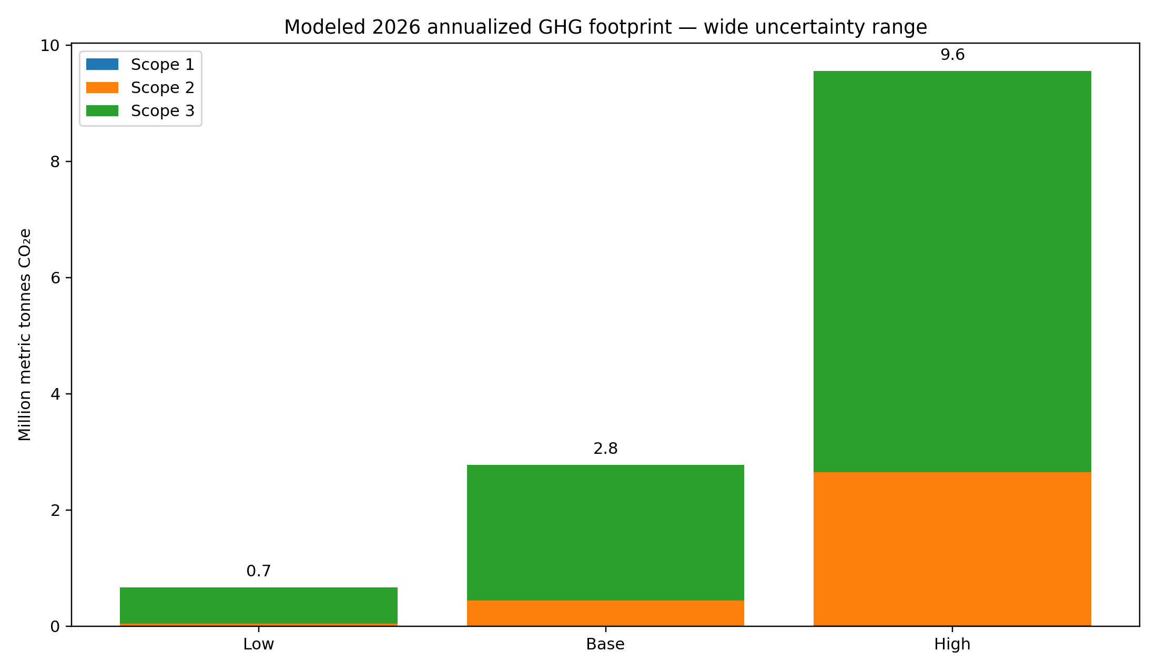
Figure 7. Modeled annual Scope 1-3 emissions range
Pre-assurance estimate. Boundaries and values will be refined as metered, supplier-allocated and controlled enterprise data mature.
Metric | 2026 estimate | Status | Method / limitation
Scope 1 | 5 ktCO2e | Estimated | Placeholder pending fuel, refrigerant and controlled-asset data.
Scope 2 | 0.44 MtCO2e | Estimated | Scenario allocation of controlled compute electricity; location-based proxy.
Scope 3 compute | 0.98 MtCO2e | Estimated | Purchased cloud/compute allocation based on assumed operational-control share.
Scope 3 capital | 1.25 MtCO2e | Estimated | Sensitivity for servers, accelerators, buildings, power and cooling equipment.
Other Scope 3 | 0.10 MtCO2e | Estimated | Business services, travel, commuting and other categories; highly incomplete.
Total | 2.78 MtCO2e | Estimated | Do not compare directly with peers without aligning boundaries and methods.

5.4 Efficiency and environmental product accounting
Efficiency is our first environmental lever because it can reduce cost, grid demand, water use and emissions simultaneously. We track and plan to disclose compute efficiency at multiple levels: useful work per accelerator-hour; energy per model training run; energy per million input, output and reasoning tokens; energy per successful user task; utilization; PUE; and avoided recomputation through caching, routing and model selection. A single average query value is insufficient for product or procurement decisions.
- We will publish a product environmental accounting methodology with system boundaries, PUE, hardware utilization and regional energy factors.
- We will report the distribution of energy by model and task class, not only a global average.
- We use smaller or specialized models where they meet quality and safety needs.
- We are increasing batching, caching, quantization, efficient inference and hardware utilization while monitoring rebound.
- We are integrating carbon, water and grid constraints into workload scheduling where safety, latency and contractual requirements permit.
OPPORTUNITY Efficiency sensitivity
A 10% reduction in our central estimated electricity demand saves about 0.40 TWh per year. At the central grid factor, that is approximately 0.14 MtCO2e before rebound and contractual instruments.

5.5 Clean energy and grid stewardship
Our infrastructure principles emphasize paying our own way for power infrastructure, funding generation and grid upgrades and avoiding the transfer of costs to local ratepayers. We have announced large Stargate infrastructure plans, renewable-powered capacity in Norway and project-specific solar, storage or generation elements in the United States. [33-36]
We distinguish annual renewable matching from local and hourly power-system impact. Future reports will include location-based and market-based Scope 2 emissions, contractual instruments, additionality, commissioning dates, hourly carbon-free energy matching, marginal grid impact, new transmission and storage, curtailment, backup generation and ratepayer protections.
Energy principle | Planned disclosure | Why it matters
Efficiency first | Useful compute per MWh, PUE, utilization, model routing and year-over-year improvement | Reduces demand at source and improves resilience.
Additional clean supply | New generation, technology, capacity, location, expected output, commercial structure and in-service date | Shows whether procurement expands the clean-energy system.
Hourly and local alignment | Load and carbon-free supply by region and hour; residual and marginal effects | Annual certificates can mask periods of high fossil generation.
Grid investment | Transmission, interconnection, storage, substations and flexible-load capabilities | AI growth can either constrain or strengthen power systems.
Ratepayer protection | Allocation of capital and operating costs; tariff treatment; community agreements | Maintains trust and avoids shifting private infrastructure costs to households.
Reliable low-carbon power | Firm clean technologies, storage, demand flexibility and backup strategy | Supports 24/7 operations without locking in high-emitting generation.

5.6 Carbon removals and claims
We prioritize deep operational and value-chain reductions before neutralization. For carbon removals, we plan to disclose project type, quantity, durability, additionality, reversal management, registry, verification, vintage and the relationship between each claim and our gross inventory. We report avoided emissions enabled by AI products or clean-energy projects separately and never deduct them from Scope 1-3 emissions. [43]

5.7 Avoided emissions and systemic conservation
We distinguish three different concepts: reductions within our Scope 1-3 inventory; avoided emissions from additional energy or infrastructure projects; and emissions reductions that our products may enable elsewhere in the economy. Only the first category reduces our corporate footprint. The others are reported separately with transparent counterfactuals, attribution limits and uncertainty.

Potential 5 GW firm clean-power pathway
We are evaluating a large-scale firm clean-power pathway with Helion Energy. Public reporting has described a potential arrangement of up to 5 GW by 2030, subject to technology performance, commercial terms, site selection, permitting, interconnection, governance and final agreements. We treat this as a conditional strategic pathway, not committed operating capacity. At a 90% capacity factor, 5 GW would generate approximately 39.42 TWh of electricity a year. [72]
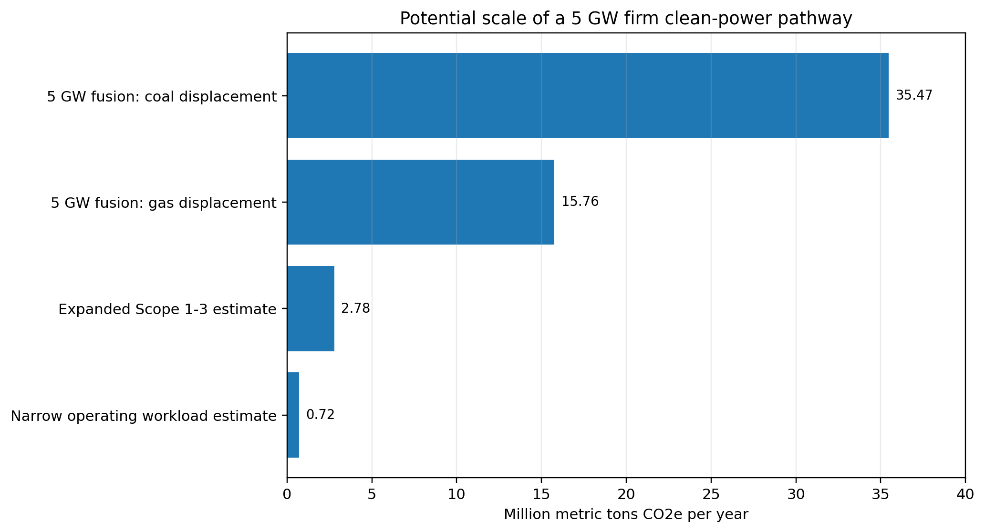
Figure 7A. Potential scale of a 5 GW firm clean-power pathway
Scenario calculation: 5 GW x 8,760 hours x 90% capacity factor. Avoided-emissions values depend on the generation actually displaced and do not reduce our Scope 1-3 inventory.
Scenario / comparator | Annual electricity | Emissions factor | Annual emissions / avoidance | Accounting treatment
Narrow current workload lens | Approximately 1.5 TWh | Blended operational and value-chain estimate | Approximately 0.72 MtCO2e | Pre-assurance footprint lens
Expanded current Scope 1-3 lens | Approximately 4.0 TWh | Broader compute and capital-goods boundary | Approximately 2.78 MtCO2e | Central pre-assurance inventory estimate
5 GW displacing natural gas | 39.42 TWh | Approximately 0.40 MtCO2e/TWh | Approximately 15.76 MtCO2e avoided | Gross grid scenario; reported separately
5 GW displacing coal | 39.42 TWh | Approximately 0.90 MtCO2e/TWh | Approximately 35.47 MtCO2e avoided | Gross grid scenario; reported separately
Under these assumptions, the gross grid emissions avoided would be approximately 5.7-12.8 times our expanded central footprint estimate and 22-49 times the narrower workload estimate. These ratios demonstrate potential scale, not ownership or a net-zero claim. Actual impact will depend on what generation is displaced, lifecycle emissions, additionality, curtailment, transmission, storage, project timing and the share contractually attributable to us.
ACCOUNTING PRINCIPLE Enabled reductions are not netted
We report our gross Scope 1-3 emissions before removals. Clean-power avoided emissions, AI-enabled reductions and wider societal conservation outcomes are reported separately and are not used to offset our inventory unless accounting standards and contractual allocation support a specific claim.

Durable carbon removal and nature-linked investment
Our workloads operate within a broader infrastructure ecosystem that is scaling durable carbon removal and ecological restoration. Microsoft has expanded its agreement with Stockholm Exergi to 5.08 million metric tons of permanent carbon removal and has supported a wider portfolio spanning direct air capture, biochar, soil carbon and forestry. Its data-center sustainability program also includes habitat projects such as the Butterfly Road pollinator initiative and White Stork wetland restoration in Sweden. These programs inform our value-chain strategy, but we do not net partner removals or restoration outcomes against our inventory unless they are contractually allocated to us and meet our claims criteria. We plan to disclose any allocated environmental attributes and to build a dedicated portfolio aligned with durability, additionality, community benefit and nature integrity. [52,73]

Advanced firm clean energy
Our long-term power strategy evaluates a portfolio of renewables, storage, demand flexibility and advanced firm clean technologies, including fusion and advanced fission. We will assess projects against lifecycle emissions, safety, nuclear security, waste, water, land, community consent, reliability, cost, schedule and regulatory readiness. We will not treat a personal investment by an executive as a corporate energy commitment; corporate procurement and investment decisions require independent governance, conflict management and board-approved controls.

AI-enabled climate innovation
AI can accelerate grid optimization, weather and climate modeling, efficient transport, precision agriculture, materials discovery, battery development, industrial efficiency, carbon capture and adaptation. The International Energy Agency estimates that widespread adoption of existing AI applications could enable approximately 1.4 Gt of CO2 reductions in 2035. A 2025 npj Climate Action analysis estimates 3.2-5.4 GtCO2e of annual reductions by 2035 across power, food and mobility under ambitious adoption scenarios. These are economy-wide potentials, not impacts attributable to us. We plan an enabled-impact methodology that measures real deployments, baselines, causality, additionality, rebound and our attributable contribution. [70-71]

The long-term conservation dividend
Our high-ambition 2050 scenario explores whether globally accessible intelligence can help enable more than 10 GtCO2e of annual gross emissions reductions through clean-power integration, efficient mobility and logistics, lower-carbon food systems, industrial optimization, materials innovation, carbon removal and faster deployment of climate capital. The 10 Gt figure is a scenario boundary, not a forecast or claim. It exceeds current published 2035 estimates and assumes major technology, policy and institutional progress, strong safeguards and active management of rebound.
The same scenario links environmental conservation with human time. As repetitive cognitive work becomes easier to automate, societies may choose to convert part of the resulting productivity into shorter working weeks, care, creativity, learning and localized ecological stewardship. We will measure whether these gains are broadly shared and whether absolute energy, water, material and land impacts remain within sustainable limits. Our core objective is not maximum computation; it is maximum durable human benefit per unit of physical resource.
6 WATER, MATERIALS AND NATURE
Managing local resource impacts across the AI infrastructure lifecycle
Environmental responsibility extends beyond carbon. Data centers, electricity generation, semiconductor manufacturing and construction affect water, materials, waste, air quality, land and biodiversity. These impacts are location-specific and require site-level data and community engagement.

6.1 Water stewardship
Our central model converts the public per-query water figure into an annual inference and training proxy of approximately 3.8 billion liters, with a low-high range of 1.8-9.0 billion liters. This is not a water inventory. The underlying boundary is unclear, and a global total cannot describe local scarcity, source type, seasonal stress or indirect water used in electricity generation.
We have announced closed-loop or low-water cooling approaches for selected Stargate projects. Our water stewardship program applies a hierarchy: avoid water-intensive siting and design; reduce withdrawal and consumption; reuse non-potable or recycled water; engage utilities and communities; restore watersheds where impacts remain; and disclose site-level performance. [33-36]
Water disclosure | Metric | Decision use
Withdrawal and consumption | Megaliters by site, source and month | Distinguishes water taken from water actually consumed.
Water stress | Share of withdrawal/consumption in high and extremely high stress basins | Prioritizes design and replenishment where local impact is greatest.
Water-use effectiveness | Liters per kWh and liters per useful compute unit | Tracks cooling and system efficiency without obscuring total growth.
Indirect water | Water consumed in electricity and hardware production | Captures major value-chain dependencies and trade-offs.
Quality and discharge | Source quality, treatment, temperature, discharge quality and incidents | Protects receiving waters and alternative users.
Community outcomes | Access, affordability, infrastructure investment, grievances and watershed benefits | Connects operational data to affected people and ecosystems.

PRINCIPLE Basin context is essential
One liter consumed in a water-abundant basin is not equivalent to one liter consumed during drought in a stressed basin. We report both absolute volumes and basin-adjusted risk, and we do not use replenishment projects to obscure local operational impacts.

6.2 Materials, embodied carbon and circularity
AI infrastructure is materially intensive. Accelerators, servers, networking equipment, batteries, cooling systems, substations and buildings require semiconductors, steel, concrete, copper, aluminum and critical minerals. Embodied emissions can be significant during rapid construction and hardware refresh cycles. We are establishing product carbon footprint and environmental product declaration requirements for strategic equipment and construction materials.
Lifecycle stage | Priority actions | Planned KPIs
Design and procurement | Right-size capacity; modularity; low-carbon concrete/steel; recycled content; repairable equipment | Embodied kgCO2e per MW/compute unit; recycled content; EPD coverage.
Manufacturing | Supplier renewable energy, process gases, water, chemicals and worker protection | Supplier Scope 1-3 data; clean-energy share; high-risk chemical controls.
Use and maintenance | Extend useful life where performance and security permit; component repair and reuse | Average server/accelerator life; reuse rate; maintenance outcomes.
Decommissioning | Secure data destruction; redeployment; resale; certified recycling; material recovery | Reuse/refurbishment rate; recycling rate; e-waste; landfill diversion.
Construction | Design efficiency, material optimization, prefabrication and waste plans | Construction waste diversion; material intensity; embodied-carbon reduction.

6.3 Waste and electronic equipment
Our zero-waste strategy covers offices, laboratories, data centers and construction. Electronic equipment requires chain-of-custody, data security and downstream-vendor due diligence. Future reports will include total waste, hazardous waste, e-waste, construction waste, reuse, recycling, energy recovery and landfill, together with the methods used to substantiate diversion claims.

6.4 Nature and biodiversity
Our dependencies on nature include water availability, land, ecosystem services, raw materials and the resilience of energy systems. Impacts can arise from data-center sites, transmission, generation, mining, semiconductor supply chains and water withdrawal. We are applying the TNFD LEAP approach - Locate, Evaluate, Assess and Prepare - to identify priority locations and value-chain interfaces. [47]
- Avoid sites and corridors with high biodiversity importance or irreplaceable habitat where feasible.
- Conduct cumulative-impact assessments for large infrastructure clusters, not only project-by-project reviews.
- Use mitigation hierarchy: avoid, minimize, restore and only then consider offsets for residual impacts.
- Screen minerals and materials for deforestation, habitat conversion, water and human-rights risks.
- Publish priority locations, dependencies, impacts, restoration outcomes and grievance processes.

6.5 Air quality, noise and local environmental health
On-site or dedicated power generation, backup generators, construction traffic and cooling equipment can affect air quality and noise. These impacts may be material even when annual corporate carbon emissions are addressed through clean-energy procurement. Future reports will disclose permitted combustion capacity, criteria-pollutant emissions, operating hours, monitoring, complaints and health-protective measures, particularly for communities already experiencing cumulative environmental burdens.

6.6 Planned environmental targets
Area | Planned target architecture | Prerequisite
Water | Basin-specific reduction and replenishment goals, supported by absolute and intensity metrics | Site inventory, source/discharge data and water-risk assessment.
Circularity | High reuse/recycling and zero routine landfill for controlled operations; construction targets | Consistent waste boundary and vendor chain-of-custody.
Embodied carbon | Project and equipment carbon budgets with supplier reduction requirements | BOM, EPD/PCF coverage and procurement controls.
Nature | No conversion of critical habitat; mitigation hierarchy and priority-site restoration | Geospatial screening and TNFD LEAP assessment.
Air quality | Best available low-emission solutions and transparent community monitoring | Asset, fuel, permit and criteria-pollutant inventory.

7 RESPONSIBLE SUPPLY CHAIN AND COMMUNITIES
Extending our standards to the workers, partners and places that enable AI
Our value chain includes cloud and data-center partners, semiconductor manufacturers, server and network suppliers, construction contractors, utilities, data and content-service providers, professional services and many other partners. Responsibility cannot stop at our legal boundary.

7.1 Supply-chain governance and due diligence
We are adopting a supplier code aligned with international labor, human-rights, environmental, ethics and health-and-safety expectations, supported by contractual requirements, risk segmentation, assessment, worker voice, corrective action and responsible disengagement. Our due-diligence program aligns with the UN Guiding Principles on Business and Human Rights and uses electronics-sector standards where relevant. [62-63]
Supplier segment | Principal ESG risks | Priority controls
Semiconductors and electronics | Energy, process gases, water, chemicals, minerals, labor conditions and geopolitical concentration | PCFs/EPDs, renewable energy, chemical controls, mineral due diligence, labor audits and resilience plans.
Data centers and cloud | Electricity, water, refrigerants, land, backup generation, security and community impacts | Allocated emissions/water, site standards, clean-energy criteria, PUE/WUE, incident and community data.
Construction and engineering | Serious injuries, migrant labor, wages, subcontracting, embodied carbon, waste and local disruption | Prequalification, worker welfare, safety leading indicators, material carbon budgets and grievance channels.
Data and content services | Fair pay, working conditions, content exposure, privacy and geographic labor risks | Worker protections, exposure controls, audit rights, living-wage analysis and grievance access.
Professional and business services | Travel, data security, labor and diversity risks | Supplier diversity, security review, emissions data and contractual conduct requirements.

7.2 Human rights
Our human-rights responsibility spans products, employees, contractors, suppliers and communities. Salient issues include privacy, non-discrimination, freedom of expression, child rights, worker welfare, safe working conditions, land and water impacts, and access to remedy. We plan periodic human-rights impact assessments for frontier-model deployment and major infrastructure, disclosure of priority findings and tracking of mitigation effectiveness.
- Board and executive oversight of salient human-rights risks.
- Human-rights criteria integrated into product, procurement, infrastructure and public-policy decisions.
- Accessible grievance mechanisms for users, workers, suppliers and communities.
- No retaliation and protection for vulnerable complainants.
- Public reporting on themes, substantiated impacts, remedy and systemic corrective actions.

7.3 Data work, content exposure and contractor welfare
Training, evaluation and safety operations may rely on specialized data work and review. Some tasks can involve exposure to disturbing material or repetitive cognitive labor. We treat these workers as part of our impact boundary even when they are employed by suppliers. Our minimum expectations include fair and timely pay, clear contracts, reasonable workload, privacy, exposure minimization, qualified psychological support, freedom of association, accessible grievance and equivalent safety expectations across geographies.
WORKER WELFARE Planned disclosure
Future reports will include the number and geography of high-risk data and content workers, supplier coverage, exposure controls, support use, complaints, corrective actions and severe incidents. We will protect worker privacy and avoid incentives to underreport harm.

7.4 Infrastructure communities
Stargate and associated infrastructure can bring investment, construction, skilled jobs, tax revenue, grid upgrades and local partnerships. They can also create concerns about power prices, water, air emissions, land use, noise, housing, traffic and emergency services. We have committed that Stargate projects will pay their own way for energy infrastructure, and we have described local plans and community engagement. [33-36]
Community impact area | Commitment / control | Evidence to disclose
Energy affordability | Fund incremental generation and grid upgrades; avoid shifting private costs to households | Tariff treatment, capital allocation, rate impact studies and actual customer-bill effects.
Jobs and economic development | Local hiring, training, supplier opportunities and durable regional capacity | Construction/permanent jobs, wages, local spend, workforce demographics and training outcomes.
Water and environment | Low-water design, permits, monitoring and mitigation | Withdrawal/consumption, air/noise data, incidents, restoration and third-party monitoring.
Public services and infrastructure | Plan for roads, emergency response, housing and public services | Payments/investment, service-demand studies and community agreements.
Community voice | Early engagement, transparent data and accessible grievance | Engagement participants, concerns, commitments, grievance volume and closure.
Long-term resilience | Avoid stranded sites; plan decommissioning and economic transition | Decommissioning security, adaptive reuse and long-term community plan.

7.5 Responsible procurement and supplier decarbonization roadmap
Phase | 2026-2027 | 2028-2029 | 2030 and beyond
Standards | Publish supplier code and high-risk requirements | Embed requirements in strategic contracts | Update based on impact evidence and leading standards.
Data | Map spend, suppliers, facilities and Scope 3 categories | Obtain primary PCFs/EPDs and allocated cloud data | Near-complete primary data for strategic emissions and risks.
Climate | Set supplier-engagement and clean-energy expectations | Require targets and transition plans for strategic suppliers | Align procurement with enterprise Scope 3 target.
Human rights | Risk screen and assess priority suppliers | Worker voice, deeper audits and remedy tracking | Demonstrate reduced salient risks and effective remedy.
Circularity | Establish hardware and construction baselines | Reuse, recycled content and low-carbon material requirements | Closed-loop systems and supplier innovation at scale.

8 GOVERNANCE, ETHICS AND ACCOUNTABILITY
Preserving mission integrity while governing high-impact technology at scale
Governance is the mechanism through which our mission, safety commitments, capital requirements and stakeholder responsibilities are reconciled. Effective governance requires clear authority, independent challenge, reliable information, transparent escalation and controls proportionate to the consequences of frontier AI.

8.1 Corporate and mission governance
Our Foundation controls OpenAI Group PBC and appoints or replaces Group directors. The Safety and Security Committee remains a Foundation committee. Our Foundation holds an economic interest and has announced major commitments to health and AI resilience. This structure creates a direct link between commercial scale and mission stewardship. [8-12]
Governance body | Current role | Impact-reporting responsibility
Foundation board | Controls the Group and protects the mission | Review mission-impact strategy, material risks, major commitments and annual report.
Group board | Oversees the public benefit corporation and enterprise | Oversee strategy, risk, performance and control environment.
Safety and Security Committee | Provides safety and security oversight within Foundation governance | Review frontier-risk governance, high-severity events and relevant public disclosures.
Executive management | Leads our operations and allocates resources | Own performance, remediation and balanced delivery across mission, safety and sustainability.
Impact Reporting Council | Planned cross-functional body | Coordinate data, controls, narratives, framework alignment and disclosure decisions.

8.2 Enterprise risk management
We manage mission, product, security, legal, financial, workforce, infrastructure, climate and societal risks through an integrated enterprise risk process. Frontier risks require specialized technical governance, and they interact with enterprise risks: energy constraints can affect reliability; talent pressure can affect safety; weak supplier controls can affect security and human rights; and public trust can influence policy and access.
Risk layer | Examples | Governance expectation
Strategic / mission | Benefit distribution, concentration, competitive dynamics, infrastructure scale | Board-approved risk appetite, scenario analysis and mission-impact measures.
Frontier model and product | Severe misuse, loss of control, harmful behavior, reliability and overreliance | Preparedness governance, evaluations, launch controls and post-deployment monitoring.
Operational | Cybersecurity, privacy, resilience, supplier failure, business continuity | Control ownership, testing, incidents, remediation and assurance.
People and culture | Critical talent, workload, conduct, retaliation, organizational change | Human-capital metrics, speak-up channels, succession and culture monitoring.
Environmental and community | Power, GHG, water, air, land, permits, ratepayer and community impacts | Site risk assessment, targets, community engagement and public performance data.
Legal and policy | Regulatory compliance, litigation, intellectual property, competition, lobbying | Legal inventory, controls, policy governance and transparent positions.

8.3 Disclosure controls and evidence
Every material quantitative metric and qualitative claim has a defined owner, source, method, boundary, evidence, review and sign-off. We are aligning impact-reporting controls with financial-reporting discipline while recognizing that many sustainability and AI metrics rely on evolving methods and supplier data.
Control element | Minimum requirement
Metric dictionary | Definition, unit, boundary, calculation, exclusions, owner, source and reporting frequency.
Evidence register | Traceable link from every material claim to source records, approvals and version history.
Data controls | Completeness, accuracy, cut-off, access, change control, reconciliation and exception management.
Narrative controls | Legal, technical, sustainability, finance and communications review; consistency with public evidence.
Judgment log | Documented methodology choices, estimates, uncertainty, disputes and final approvals.
Assurance readiness | Control testing, evidence retention, issue remediation and management representation.

8.4 Ethics, compliance and responsible business practices
Future reports will cover our code of conduct, anti-corruption, conflicts, competition, sanctions, export controls, political activity, lobbying governance, gifts, investigations, discipline and training. Where disclosure could compromise security or privacy, we will provide meaningful aggregate information. Our policy advocacy is governed for consistency with our mission, safety commitments and sustainability positions.
GOVERNANCE Planned policy transparency standard
For material policy positions, we plan to disclose the issue, desired outcome, evidence base, principal trade-offs and governance approval. We also plan a consistent global methodology for political contributions, significant lobbying and positions taken through trade associations.

8.5 Transparency, external challenge and remedy
Trust requires more than self-reporting. We continue external safety assessments and are expanding independent challenge across impact topics through assurance, academic research, civil-society engagement, community monitoring and worker voice. Future reports will include material grievances and remedies for users, workers, suppliers and communities. [15-17,21-23]

8.6 Mission and ESG reporting governance model
Accountability | Primary responsibilities | Key deliverables
Board / Foundation committee | Oversight, mission alignment, material risk, major commitments, report approval | Annual impact review, risk challenge, approved targets and report.
Executive sponsor | Enterprise accountability, resources, escalation, cross-functional alignment | Quarterly performance and issue review; management representation.
Head of ESG Reporting & Operations | Program plan, cadence, data governance, controls, frameworks, narrative and assurance | Controlled reporting process, executive materials, indices and final delivery.
Functional owners | Performance and evidence for safety, product, people, finance, infrastructure, supply chain and policy | Source data, controls, analysis, actions and sign-off.
Internal audit / assurance | Independent evaluation of controls and selected metrics | Readiness findings, assurance opinion and remediation tracking.
Stakeholders and experts | Challenge materiality, methods, impacts and priorities | Challenge, response log and public feedback summary.

9 CLIMATE RISK, OPPORTUNITIES AND RESILIENCE
A TCFD- and IFRS S2-aligned assessment of AI infrastructure
Climate change affects our infrastructure, supply chain, costs, communities and ability to deliver reliable AI services. At the same time, the transition to a low-carbon economy creates opportunities for efficient computing, new clean-energy markets, grid services and AI-enabled climate solutions.

9.1 Governance
We are formalizing board-level oversight of material climate risk and executive ownership spanning Infrastructure, Finance, Risk, Legal, Procurement, Sustainability and Product. We integrate climate analysis into site selection, capital allocation, energy procurement, supplier strategy, business continuity and public commitments. The Head of ESG Reporting & Operations coordinates disclosure and controls while operational leaders retain performance ownership.

9.2 Risk and opportunity inventory
Category | Risk / opportunity | Time horizon | Potential impact | Primary response
Transition risk | Electricity price and carbon-cost exposure | Short-medium | Higher operating cost; regional competitiveness; contract volatility | Efficiency, long-term clean supply, flexible load, geographic diversification.
Transition risk | Permitting, grid interconnection and clean-energy scarcity | Short-medium | Delayed capacity and growth constraints | Early grid planning, project funding, transmission/storage and technology portfolio.
Transition risk | Embodied-carbon regulation and customer requirements | Medium | Higher equipment/build costs and procurement constraints | Supplier PCFs, low-carbon materials, circularity and design optimization.
Transition risk | Community opposition and ratepayer concerns | Short-long | Delay, litigation, reputational harm and loss of social license | Pay-own-way principles, transparent studies, benefits, engagement and grievance.
Physical risk | Extreme heat and drought | Short-long | Cooling limits, higher energy demand, water stress and equipment degradation | Low-water design, heat-resilient equipment, diversified sites and emergency plans.
Physical risk | Flood, storm, wildfire and smoke | Short-long | Outages, asset damage, access constraints and worker health impacts | Hazard screening, resilient design, redundancy, insurance and supplier continuity.
Supply-chain risk | Climate disruption to semiconductors, minerals and logistics | Medium-long | Shortages, cost escalation and delays | Multi-sourcing, inventory, supplier resilience and regional diversification.
Opportunity | Abundant clean, firm and flexible energy | Medium-long | Lower emissions and cost; grid value; faster deployment | Additional generation, storage, advanced energy, demand response and heat reuse.
Opportunity | AI for mitigation and adaptation | Medium-long | Customer and societal value; accelerated climate solutions | Evidence-based product programs with avoided-emissions methodologies.
Transition risk | Cognitive rebound and rapid workload growth | Short-long | Absolute electricity, water and material demand may rise despite lower intensity | Efficiency per useful task, clean-power coverage, absolute caps/guardrails and demand governance.

9.3 Scenario design
We use three qualitative climate scenarios informed by NGFS and IPCC pathways. They are not forecasts. They test resilience under different combinations of transition policy, technology, energy-system change and physical warming. [64-67]
Scenario | Climate / policy context | AI infrastructure implications
Orderly Net Zero 2050 / 1.5 C | Early, coordinated policy; rapid power-sector decarbonization; high clean-energy investment; increasing carbon prices | High near-term transition requirements but strong clean-power availability over time. Competitive advantage from efficiency, additional clean supply, supplier targets and durable removals.
Delayed / fragmented transition | Insufficient early action followed by abrupt policy tightening; uneven regional progress; supply-chain bottlenecks | Highest transition volatility: carbon and energy costs rise rapidly; permitting and equipment constraints intensify; potential stranded fossil infrastructure.
Current policies / approximately 3 C | Limited additional climate policy; slower decarbonization; greater chronic and acute physical impacts | Lower direct policy cost but much higher heat, water, storm, wildfire, insurance, reliability and community-resilience risk.

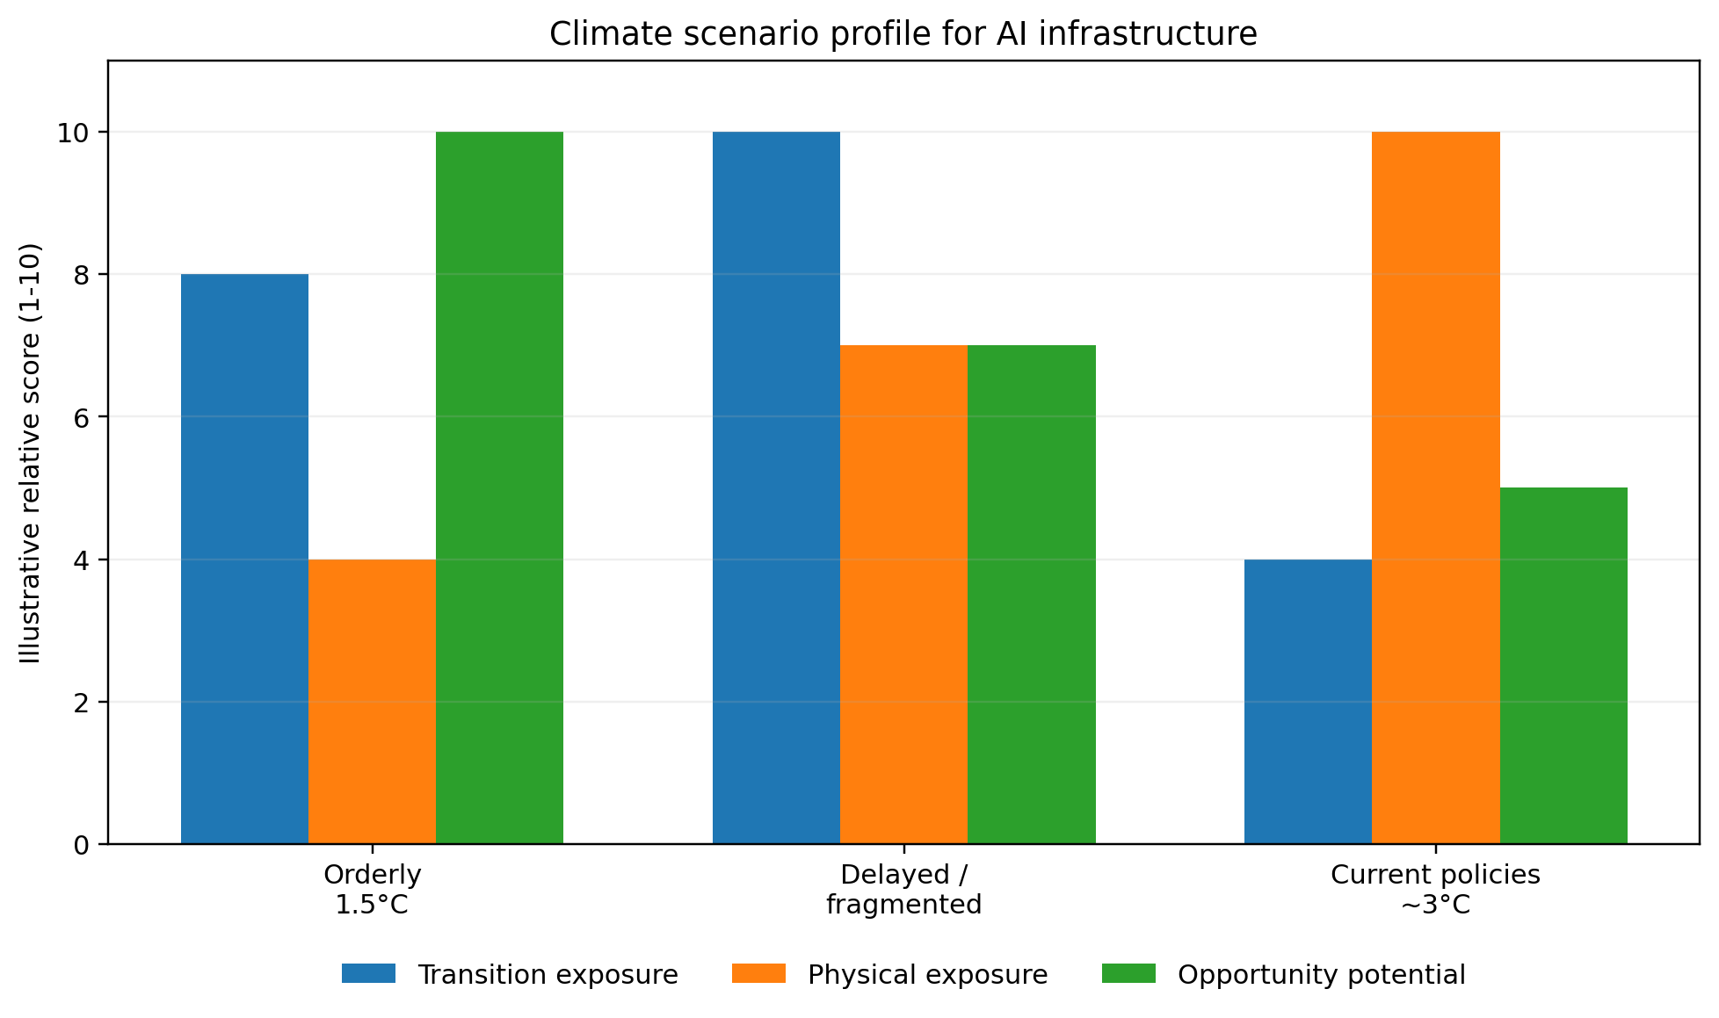
Figure 8. Climate scenario profile for AI infrastructure
Relative scores summarize our qualitative analysis; they are not probabilities or financial forecasts.

9.4 Quantitative sensitivities
At our central estimated load of 4.0 TWh, every $10/MWh change in average electricity cost changes annual operating cost by approximately $40 million before hedging and contractual structures. If a carbon price applied to our central estimated compute emissions of 1.41 MtCO2e, gross annual exposure would be approximately $70 million at $50/tCO2e, $211 million at $150/tCO2e and $351 million at $250/tCO2e. These sensitivities are scenario analyses, not forecasts or current liabilities.
Sensitivity | Scenario result | Interpretation
$10/MWh electricity-price change | Approximately $40 million/year | Efficiency, contracting, location and flexible demand can materially affect cost.
10% electricity-efficiency improvement | Approximately 0.40 TWh and 0.14 MtCO2e/year | Savings may be offset by growth unless absolute demand is also managed.
$50/tCO2e on compute emissions | Approximately $70 million/year | Illustrates direct/implicit carbon-cost exposure.
$150/tCO2e on compute emissions | Approximately $211 million/year | Represents stronger transition-policy sensitivity.
$250/tCO2e on compute emissions | Approximately $351 million/year | Stress case for high-carbon operations or supply.

9.5 Scenario implications by time horizon
Time horizon | Orderly transition | Delayed transition | Current policies / high warming
Short term: 0-3 years | Competition for interconnection and clean-energy projects; carbon accounting expectations increase | Policy uncertainty and uneven standards; temptation to lock in fossil generation | Rapid load growth; heat/water events increasingly affect permits and operations.
Medium term: 3-10 years | Clean grids and firm low-carbon resources expand; efficient sites gain advantage | Abrupt carbon, permitting and procurement pressure; stranded-asset risk rises | Physical risks, insurance and community adaptation costs become material.
Long term: 10+ years | Lower-carbon operations with residual embodied and land/nature impacts | High transition cost followed by partial stabilization | Severe heat, water and disaster exposure; supply-chain and migration impacts.

9.6 Resilience actions
- Integrated siting: screen heat, drought, flood, wildfire, grid carbon, water stress, biodiversity, community vulnerability and cumulative impacts before committing capital.
- Diversified energy: combine efficiency, storage, renewables, advanced firm clean power, demand flexibility and carefully controlled backup.
- Supplier resilience: map semiconductor, equipment, construction and utility dependencies; require business-continuity and climate plans.
- Physical hardening: design for future rather than historical weather, including cooling, flood, smoke, fire and grid-outage conditions.
- Community resilience: co-invest in grid, water, emergency and workforce capacity that benefits both the project and the region.
- Financial integration: include energy, carbon, water and physical-risk sensitivities in investment cases and impairment reviews.

9.7 TCFD / IFRS S2 conclusion
Our central climate conclusion is that environmental performance and strategic resilience are aligned. The orderly-transition scenario requires faster near-term action but offers the most stable long-term pathway. The delayed scenario creates the greatest transition volatility. The current-policies scenario may appear cheaper in the near term but produces the highest physical and community risk. Our transition plan prioritizes efficient computing, additional clean and reliable electricity, supplier decarbonization, low-water and climate-resilient design, transparent community commitments, management of cognitive rebound and controlled Scope 1-3 reporting.
10 PERFORMANCE DATA AND METHODOLOGY
Building a controlled baseline for transparent, comparable and assured reporting
Our reporting is designed so stakeholders can distinguish measured performance from estimates, understand boundaries and methods, and trace material claims to reliable evidence. This chapter consolidates current indicators, pre-assurance estimates and our data collection, control and assurance plans.

10.1 Environmental performance summary
Metric | 2026 value | Status | Method / limitation
Operating electricity | Low 1.90 | Central 4.02 | High 9.47 TWh | Estimated | Public product volumes and energy assumptions; includes inference and training/R&D.
Scope 1 GHG | Central 5 ktCO2e | Estimated | Placeholder pending controlled-asset, fuel and refrigerant data.
Scope 2 GHG | Central 0.437 MtCO2e | Estimated | Scenario location-based allocation; a market-based result is planned for future reporting.
Scope 3 GHG | Central 2.334 MtCO2e | Estimated | Compute supplier allocation, capital sensitivity and incomplete other categories.
Total Scope 1-3 | Low 0.67 | Central 2.78 | High 9.55 MtCO2e | Estimated | Not comparable to peer assured inventories without boundary normalization.
Water proxy | Low 1.80 | Central 3.80 | High 8.96 bn L | Estimated | Does not identify source, basin, withdrawal vs. consumption or indirect water.
Waste and e-waste | Collection in progress | Data collection and disclosure plans | Require site and project data with reuse/recycling chain of custody.
Land and biodiversity | Collection in progress | Data collection and disclosure plans | Require geospatial footprint, priority locations, mitigation and restoration.
Air pollutants | Collection in progress | Data collection and disclosure plans | Require controlled and dedicated generation, backup and construction data.

10.2 Social and governance performance summary
Metric | 2026 value | Status | Method / limitation
Weekly active users | More than 900 million in 2026 [5] | Current performance | Scale indicator; not a direct outcome or benefit measure.
API throughput | Approximately 15 billion tokens per minute in 2026 [5] | Current performance | Run-rate; methodology and annual average planned for future disclosure.
Geographic diffusion | Fast relative growth reported in Africa, Asia and lower-HDI markets [7] | Current performance | Detailed country, income, language and outcome table collection in progress.
Foundation commitments | $25 billion focus on health and AI resilience [9] | Current performance | Future reports will include annual grant, beneficiary, outcome and evaluation data.
Safety evaluations | Preparedness, system-card and external-evaluation processes published | Current performance | We are building a single annual cross-product KPI table.
Privacy and security | Certifications, encryption and business-data commitments published | Current performance | Future reports will include annual incident, rights-request and control-effectiveness metrics.
Employees | Collection in progress | Data collection and disclosure plans | We are building a controlled workforce dataset.
Health and safety | Collection in progress | Data collection and disclosure plans | We are establishing a global boundary, incident data, leading indicators and psychosocial metrics.
Supplier performance | Collection in progress | Data collection and disclosure plans | We are collecting supplier code, coverage, audits, findings, remedy and emissions.
Community impact | Project principles and announcements published | Current performance / data collection plan | Future reports will include site-level jobs, ratepayer, water, air, grievance and benefit outcomes.

10.3 Estimated footprint methodology
Our environmental model is transparent and editable. It estimates ChatGPT inference energy from daily message volume and average energy per query, derives an API sensitivity from tokens per query and our reported tokens per minute, and estimates training, evaluation and research as a percentage of inference. Electricity is multiplied by a grid-emissions factor, emissions are allocated between Scope 2 and Scope 3 based on operational-control assumptions, and capital goods and other Scope 3 sources are added as sensitivities. We will replace these assumptions with telemetry, metered data and supplier allocations.
Model input | Low | Central | High | Rationale / limitation
Daily ChatGPT messages | 2.5bn | 3.3bn | 4.5bn | Derived from public usage scale; annual average is planned for future disclosure.
Tokens per average query | 2000 | 1000 | 500 | Used to convert average query energy into an energy/token sensitivity.
Derived Wh/token | 0.000170 | 0.000340 | 0.000680 | Pre-assurance conversion factor; model and token type vary materially.
Grid factor | 0.20 | 0.35 | 0.55 kg/kWh | Location-based proxy; actual regional and hourly factors unknown.
Scope 3 capital sensitivity | 0.25 | 1.25 | 4.00 MtCO2e | Large uncertainty due to equipment, buildings, ownership and useful life.

10.4 Cognitive-substitution and knowledge-work methodology
Our cognitive-substitution model estimates workplace emissions from allocated office energy, commuting, devices, home working, business travel and other digital services. The central worker footprint is 1.93 tCO2e/year, while a higher-bound sensitivity uses 4.9-5.8 tCO2e/year. Task allocations divide annual emissions by work-hours and estimated task time. AI values use incremental inference electricity: 5 Wh for a 100-line code draft, 1.5 Wh per image query and stated standard- and low-carbon-grid factors. Results compare emissions intensity, not complete lifecycle footprints, and exclude human review, devices, training, capital goods and rebound. Lines of code and pages are scenario output units, not universal productivity or quality measures.
Component | Central assumption | Annual emissions
Allocated office electricity and gas | 125 ft2 per worker; U.S. office EUI and fuel shares | 801 kgCO2e
Commuting | 12 miles round trip, 3 days/week, 46 weeks | 662 kgCO2e
Laptop and home office | Laptop annualized over four years plus 200 kWh home electricity | 118 kgCO2e
Travel and other IT | Scenario assumptions | 350 kgCO2e
Total baseline | Sum of components | 1931 kgCO2e
AI use | 40 interactions/day, 220 days, complexity multiplier 5 | 5.9 kgCO2e

10.5 Avoided-emissions methodology
We estimate avoided emissions as project electricity or useful heat multiplied by the difference between a counterfactual emissions factor and a project lifecycle factor, adjusted for attributable share. The 5 GW firm clean-power scenario uses a 90% capacity factor and tests displacement of natural gas and coal. Economy-wide enabled-impact scenarios use published IEA and peer-reviewed ranges. We report all avoided and enabled impacts separately from our corporate inventory, do not add overlapping potentials, and require evidence of counterfactual, additionality, causality, lifecycle impacts, rebound and contractual attribution before making a claim.

10.6 2050 methodology
Our 2050 model estimates potential time saved from people with access, weekly time savings and annual weeks of use. The leisure dividend is the share of time that societies convert into reduced working time, care, learning, community activity and rest; remaining gains are expressed as retained output. Gross workplace emissions savings depend on actual reductions in commuting, occupied space, travel, materials and energy. Net climate scenarios subtract global AI-system emissions and test rebound. The high-ambition 10 GtCO2e conservation boundary is a scenario, not a forecast or attributable impact.

10.7 Data quality and limitations
Limitation | Potential effect | Planned evidence
Enterprise asset and contract boundary in development | Misclassification between Scope 1, 2 and 3; omissions or double counting | Legal-entity, asset, lease, cloud and operational-control register.
Product volumes are point-in-time run-rates | Annual energy may be over- or understated | Monthly messages/tokens by product, model, region and modality.
Average energy per query lacks full methodology | Cannot accurately model complex reasoning, images, audio or video | Telemetry by model/task, PUE, hardware, utilization and data-center region.
Supplier-allocated compute emissions in development | Grid factors and renewable claims may not reflect actual service | Supplier energy, emissions, water and contractual instrument allocations.
Capital goods estimated by sensitivity | Potentially largest Scope 3 uncertainty | Bills of material, PCFs/EPDs, ownership, useful life and construction data.
We are consolidating social outcomes | Access can be confused with realized benefit | Disaggregated outcome studies, user research and independent evaluation.
Workforce and supply-chain data collection is in progress | Cannot assess standard social performance | Headcount, demographics, safety, pay, audits, grievances and remedy.
Avoided impacts lack attribution/additionality proof | Risk of overclaiming positive impact | Counterfactuals, contracts, metered data, lifecycle factors and third-party review.

10.8 Assurance roadmap
Stage | Scope | Control priorities | External assurance
Readiness - 2026 | Define boundary, material topics, owners and methods | Evidence register, metric dictionary, reconciliations, review and issue log | Independent readiness assessment; pre-assurance reporting.
Initial assurance - 2027 | Scope 1-3, energy, water, selected workforce/access/safety metrics | Source-system controls, supplier evidence, estimates, management review | Limited assurance over selected metrics and index consistency.
Expanded assurance - 2028-2029 | Broader environmental/social dataset and key qualitative claims | Automated controls, internal audit, site and supplier testing | Limited assurance across core report; selected reasonable assurance.
Mature reporting - 2030+ | Integrated mission, ESG, financial and risk information | Continuous monitoring, control certification and restatement protocol | Reasonable assurance where standards and evidence support it.

10.9 Data collection and disclosure plan for the next report
- Legal-entity and organizational-boundary memorandum, including controlled assets and compute/service contracts.
- Monthly electricity, fuel, refrigerant and water data by site, provider and operational-control status.
- Inference, training, evaluation and research telemetry reconciled to product volumes.
- Cloud and data-center supplier allocations for energy, GHG, water, renewable instruments and PUE/WUE.
- Capital project bills of material, hardware purchases, PCFs/EPDs, construction waste and useful-life assumptions.
- Employee, contractor, representation, pay, turnover, learning, engagement, safety and ethics data.
- Supplier universe, risk segmentation, assessments, corrective actions, worker grievances and Scope 3 data.
- Product safety, privacy, security, enforcement, appeals, accessibility and outcome metrics using stable definitions.
- Community jobs, local spend, ratepayer, water, air, noise, public-service and grievance evidence by major site.
- Foundation grants, beneficiaries, outcomes, additionality, evaluation and governance information.
11 REPORTING INDICES
Mapping to leading sustainability and climate frameworks
The indices below show where we address relevant disclosures and where data collection, control or applicability work continues. They do not represent a formal claim of full compliance with GRI, SASB, IFRS S2 or TNFD.
NAVIGATION Index status
"Addressed" means the topic is substantively covered. "Partial" means reporting is in place but a metric, boundary or control is still maturing. "Planned" identifies a program or disclosure in our roadmap. "Data collection and disclosure plans" identifies information scheduled for future reports. "Not applicable / to assess" requires a documented applicability determination.

11A GRI CONTENT INDEX
Mapping to GRI Universal and Topic Standards
Disclosure | Topic | Report location | Status | Planned disclosure progression
GRI 2-1 | Organizational details | About us and our reporting approach | Partial | Future reports will include legal entities, headquarters and operating footprint.
GRI 2-2 | Entities included in reporting | Reporting boundary | Partial | We are completing the controlled consolidation boundary.
GRI 2-3 | Reporting period, frequency and contact point | Reporting basis | Partial | Reporting period addressed; an approved contact point is planned for future reporting.
GRI 2-4 | Restatements of information | Methodology | Data collection and disclosure plans | Restatement policy planned for future reporting.
GRI 2-5 | External assurance | Assurance roadmap | Partial | Limited assurance is planned as controls mature.
GRI 2-6 | Activities, value chain and business relationships | About us; responsible supply chain and communities | Addressed | Quantitative supplier/value-chain profile planned for future reporting.
GRI 2-7 | Employees | Our people | Data collection and disclosure plans | Headcount and demographics under development.
GRI 2-8 | Workers who are not employees | Our people; supply chain | Data collection and disclosure plans | Contractor and data-worker metrics planned for future reporting.
GRI 2-9 | Governance structure and composition | Governance | Partial | Our structure is addressed; future reports will include composition and diversity details.
GRI 2-10 | Nomination and selection of highest governance body | Governance | Partial | Selection criteria/process not fully addressed.
GRI 2-11 | Chair of highest governance body | Governance | Data collection and disclosure plans | Official governance details planned for future reporting.
GRI 2-12 | Oversight of management of impacts | Governance | Partial | Public roles plus planned reporting governance.
GRI 2-13 | Delegation of responsibility for impacts | Impact strategy; governance | Planned | Operating model planned, not confirmed.
GRI 2-14 | Role in sustainability reporting | Governance | Planned | Board/report approval process planned.
GRI 2-15 | Conflicts of interest | Governance | Partial | Policy and case data planned for future reporting.
GRI 2-16 | Communication of critical concerns | Governance; employee voice | Partial | Channels discussed; quantitative data under development.
GRI 2-17 | Collective knowledge of governance body | Governance | Data collection and disclosure plans | Skills and training matrix planned for future reporting.
GRI 2-18 | Evaluation of highest governance body | Governance | Data collection and disclosure plans | Evaluation process planned for future reporting.
GRI 2-19/20 | Remuneration policies/process | Our people; governance | Data collection and disclosure plans | Executive/board remuneration information not included.
GRI 2-22 | Statement on sustainable development strategy | Leadership message | Addressed | Scenario corporate statement.
GRI 2-23/24 | Policy commitments and embedding | Strategy; responsible AI; supply chain | Partial | Policies discussed; implementation metrics incomplete.
GRI 2-25/26 | Remediation and advice/concern mechanisms | Responsible AI; governance | Partial | Appeals and channels discussed; outcome metrics in development.
GRI 2-27 | Compliance with laws and regulations | Governance | Data collection and disclosure plans | Significant non-compliance and fines data planned for future reporting.
GRI 2-28 | Membership associations | Governance | Data collection and disclosure plans | Material memberships and positions planned for future reporting.
GRI 2-29 | Stakeholder engagement | Reporting basis | Partial | Stakeholder map and planned engagement; validation results are planned for future reporting.
GRI 2-30 | Collective bargaining agreements | Our people | Data collection and disclosure plans | Coverage and approach planned for future reporting where applicable.
GRI 3-1 | Process to determine material topics | Materiality | Partial | Preliminary pre-assurance assessment; stakeholder validation planned for future reporting.
GRI 3-2 | List of material topics | Impact strategy | Addressed | Current material-topic list addressed; stakeholder validation is planned.
GRI 3-3 | Management of material topics | Chapters 2-9 | Partial | Management approaches described; performance and effectiveness incomplete.
GRI 201-2 | Financial implications of climate change | Climate risk | Partial | Quantitative sensitivities, not financial-statement estimates.
GRI 203-2 | Significant indirect economic impacts | Societal impact; communities | Partial | Scenarios and narrative; measured outcomes planned for future reporting.
GRI 205 | Anti-corruption | Governance | Partial | Approach planned; training/case data under development.
GRI 302 | Energy | Climate and energy | Partial | Modeled energy; controlled data and reduction metrics planned for future reporting.
GRI 303 | Water and effluents | Water | Partial | Modeled proxy and approach; site data planned for future reporting.
GRI 304 | Biodiversity | Nature | Partial | Management approach planned; location/impact data planned for future reporting.
GRI 305 | Emissions | Climate and energy | Partial | Modeled Scope 1-3; a controlled and assured inventory is planned.
GRI 306 | Waste | Materials and circularity | Data collection and disclosure plans | Actual waste and circularity data planned for future reporting.
GRI 308 | Supplier environmental assessment | Supply chain | Planned | Program and metrics planned.
GRI 401 | Employment | Our people | Data collection and disclosure plans | Hiring, turnover and benefits data planned for future reporting.
GRI 403 | Occupational health and safety | Our people; supply chain | Partial | Risk framework described; incident/coverage data under development.
GRI 404 | Training and education | Our people | Data collection and disclosure plans | Learning hours and program data planned for future reporting.
GRI 405/406 | Diversity, equal opportunity and non-discrimination | Our people | Partial | Policy addressed; quantitative data and incidents are planned for future reporting.
GRI 408/409 | Child labor and forced labor | Supply chain | Planned | Supplier due diligence program planned for future reporting.
GRI 412 | Human rights assessment | Supply chain; responsible AI | Planned | Human-rights impact assessment process planned.
GRI 413 | Local communities | Communities | Partial | Principles and planned metrics; site outcomes planned for future reporting.
GRI 414 | Supplier social assessment | Supply chain | Planned | Supplier coverage, findings and remedy planned for future reporting.
GRI 418 | Customer privacy | Responsible AI | Partial | Policies and controls addressed; annual incident and request metrics are planned for future reporting.

11B SASB INDEX
Software & IT Services and Internet Media & Services mapping
Code | Accounting metric / topic | Report location | Status | Planned disclosure progression
TC-SI-130a.1 | Energy consumed; grid electricity; renewable percentage | Climate and energy | Partial | Modeled energy only; actual energy mix and renewable share planned for future reporting.
TC-SI-130a.2 | Water withdrawal/consumption and high-stress locations | Water | Partial | Modeled global proxy; site/basin data planned for future reporting.
TC-SI-130a.3 | Integration of environmental considerations into data-center planning | Climate; water; communities | Addressed / partial | Approach described; implementation data planned for future reporting.
TC-SI-220a.1 | Privacy policies and behavioral advertising | Responsible AI | Partial | Privacy approach discussed; product-specific metrics planned for future reporting.
TC-SI-220a.2 | Users whose information is used for secondary purposes | Responsible AI | Data collection and disclosure plans | Applicability and quantitative data planned for future reporting.
TC-SI-220a.3 | Government/law-enforcement information requests | Responsible AI | Partial | Our transparency approach is in place; we plan to link the full reporting dataset.
TC-SI-220a.4 | Monetary losses from user-privacy legal proceedings | Responsible AI / governance | Data collection and disclosure plans | Official legal disclosure planned for future reporting.
TC-SI-230a.1 | Data breaches and users affected | Responsible AI | Data collection and disclosure plans | Security incident metrics planned for future reporting.
TC-SI-230a.2 | Data-security risk identification and management | Responsible AI | Addressed | Certifications and governance discussed; effectiveness data limited.
TC-SI-330a.1 | Employees in foreign countries and contractors | Our people | Data collection and disclosure plans | Workforce geography and contractor data planned for future reporting.
TC-SI-330a.2 | Employee engagement percentage | Our people | Data collection and disclosure plans | Survey method and result planned for future reporting.
TC-SI-330a.3 | Gender and racial/ethnic representation | Our people | Data collection and disclosure plans | Representation data planned for future reporting.
TC-SI-520a.1 | Legal proceedings associated with anti-competitive behavior | Governance | Data collection and disclosure plans | Official legal disclosure planned for future reporting.
TC-SI-550a.1 | Performance issues and service disruptions | Governance / resilience | Data collection and disclosure plans | System availability and disruption data planned for future reporting.
TC-SI-550a.2 | Business-continuity risk management | Governance; climate risk | Partial | Climate resilience addressed; broader continuity data planned for future reporting.
TC-IM-220a.1 | Privacy policies and targeted advertising | Responsible AI | Partial | Applicability varies by product/business model.
TC-IM-220a.2 | User information used for secondary purposes | Responsible AI | Data collection and disclosure plans | Applicability and metric definition planned for future reporting.
TC-IM-230a.1/2 | Data security incidents and management | Responsible AI | Partial | Governance is addressed; we are consolidating event metrics.
TC-IM-330a.1/2/3 | Workforce engagement and diversity | Our people | Data collection and disclosure plans | Standard human-capital data planned for future reporting.
TC-IM-520a.1 | Anti-competitive behavior | Governance | Data collection and disclosure plans | Official legal data planned for future reporting.
TC-IM-550a.1/2 | Content governance and political integrity / platform impacts | Responsible AI; governance | Partial | Usage policies and transparency are addressed; we are defining stable impact KPIs.
Activity metrics | Users, data processing capacity, product activity | At a glance; societal impact | Partial | Weekly users and API throughput are included; we are developing standard annual averages.

11C TCFD / IFRS S2 INDEX
Climate-related financial disclosures
Pillar / requirement | Disclosure | Report location | Status | Planned disclosure progression
Governance (a) | Board oversight of climate-related risks and opportunities | Climate risk 9.1; governance 8.1 | Partial | Planned oversight; approved charter and activity data planned for future reporting.
Governance (b) | Management role in assessing and managing climate matters | Climate risk 9.1; governance 8.6 | Planned | Management operating model planned.
Strategy (a) | Climate risks and opportunities over short, medium and long term | Climate risk 9.2 and 9.5 | Addressed | Qualitative inventory and horizons provided.
Strategy (b) | Impact on business, strategy and financial planning | Climate risk 9.4-9.7 | Partial | Sensitivities provided; integrated financial planning evidence planned for future reporting.
Strategy (c) | Resilience under climate scenarios | Climate risk 9.3-9.7 | Addressed / partial | Three scenarios assessed qualitatively; asset-level quantification planned for future reporting.
Risk management (a) | Processes for identifying and assessing climate risk | Climate risk; materiality | Partial | Planned screening and ERM integration.
Risk management (b) | Processes for managing climate risk | Climate risk 9.6 | Partial | Actions described; performance and accountability planned for future reporting.
Risk management (c) | Integration into overall risk management | Governance 8.2; climate risk 9.1 | Planned | ERM integration planned.
Metrics and targets (a) | Metrics used to assess climate risks/opportunities | Climate and energy; performance data | Partial | Modeled GHG/energy and planned operational metrics.
Metrics and targets (b) | Scope 1, 2 and 3 GHG emissions and related risks | Climate and energy | Partial | Modeled range; actual GHG Protocol inventory planned for future reporting.
Metrics and targets (c) | Targets and performance | Impact strategy 1.4; climate 5.6 | Planned | Target architecture planned; we will formalize an enterprise climate target after completing the controlled baseline.
IFRS S2 industry metrics | Industry-based metrics relevant to software/internet services | SASB index | Partial | Applicability and primary data planned for future reporting.

11D TNFD INDEX
Nature-related dependencies, impacts, risks and opportunities
TNFD pillar | Disclosure | Report location | Status | Planned disclosure progression
Governance A | Board oversight of nature dependencies, impacts, risks and opportunities | Nature; governance | Planned | Formal oversight and reporting planned for future reporting.
Governance B | Management role | Nature; reporting governance | Planned | Functional ownership and escalation planned for future reporting.
Governance C | Human rights policies and engagement with affected stakeholders | Supply chain; communities | Partial | Approach planned; policy and outcomes planned for future reporting.
Strategy A | Nature dependencies, impacts, risks and opportunities | Water, materials and nature | Partial | High-level assessment; location/value-chain analysis planned for future reporting.
Strategy B | Effects on business model, value chain and financial planning | Nature; climate risk | Partial | Narrative provided; financial integration planned for future reporting.
Strategy C | Resilience under scenarios | Climate risk | Partial | Climate scenarios included; explicit nature scenarios not completed.
Strategy D | Priority locations | Water and nature | Data collection and disclosure plans | Geospatial location disclosure and sensitivity planned for future reporting.
Risk management A(i) | Direct operations identification and assessment process | Nature | Planned | LEAP process planned.
Risk management A(ii) | Upstream/downstream value-chain assessment | Supply chain; nature | Planned | Supplier and materials mapping planned for future reporting.
Risk management B | Management of nature risks and opportunities | Nature | Planned | Mitigation hierarchy and controls planned.
Risk management C | Integration with enterprise risk management | Governance; climate risk | Planned | Integration planned for future reporting.
Metrics and targets A | Metrics to assess material nature risks/opportunities | Water, materials and nature | Partial | Metric architecture planned; controlled data in development.
Metrics and targets B | Metrics to manage dependencies and impacts | Water, materials and nature | Partial | Water/circularity/nature KPIs planned.
Metrics and targets C | Targets and performance | Nature 6.6 | Planned | We plan to formalize nature targets after completing location and value-chain assessment.

11E UN SUSTAINABLE DEVELOPMENT GOALS
Contribution and risk alignment
Goal | Potential contribution | Risks and safeguards
SDG 3 - Good health and well-being | Foundation health focus; potential support for research and care | Safety of health information, access disparities, mental-health risks and validation.
SDG 4 - Quality education | Tutoring, translation, feedback and AI literacy | Academic integrity, inequitable access, privacy and overreliance.
SDG 5 / 10 - Equality | Broad access and tools that can reduce expertise barriers | Bias, language gaps, digital divide and unequal capture of productivity gains.
SDG 7 - Clean energy | Potential to expand clean-energy demand, storage and grid investment | Rapid load growth, fossil lock-in and affordability impacts.
SDG 8 - Decent work | Productivity, new occupations and skills | Displacement, work intensification, worker surveillance and contractor conditions.
SDG 9 - Industry, innovation and infrastructure | Frontier research, digital infrastructure and scientific innovation | Resource intensity, concentration and community/infrastructure impacts.
SDG 12 - Responsible consumption and production | Efficiency, hardware circularity and supplier requirements | Short equipment cycles, e-waste, minerals and embodied carbon.
SDG 13 - Climate action | AI-enabled climate applications and clean infrastructure | Operational GHG growth and rebound.
SDG 16 - Strong institutions | Access to information, public-service support and safety governance | Misinformation, cybersecurity, surveillance, due process and institutional dependence.
SDG 17 - Partnerships | Research, government, community, nonprofit and infrastructure partnerships | Accountability, conflicts, power imbalances and transparent outcomes.

APPENDIX A DETAILED ASSUMPTIONS AND DATA COLLECTION PLANS
Our roadmap for completing a controlled, externally assured reporting system
Area | Current estimation assumption | Main uncertainty | Data collection plan
Average query energy | Approximately 0.3-0.34 Wh for a typical text query | System boundary, model mix, modalities and regional infrastructure | Energy by model, modality, token type, reasoning effort, hardware, utilization, PUE and region.
ChatGPT activity | 2.5-4.5 billion messages/day scenario | Annual average and growth trajectory | Monthly messages by model, plan, geography and modality.
API activity | 15 billion tokens/minute run-rate | Annual average, input/output/reasoning mix, caching and batching | Monthly tokens and requests by model, region, token type and serving method.
Training and research | 15-60% of inference energy | Run size/count, failed runs, evaluations and utilization | Run-level energy, hardware hours, evaluation/research compute and PUE.
Electricity carbon factor | 0.20-0.55 kgCO2e/kWh | Regional/hourly mix and contractual instruments | Metered load, location-based factors, supplier-specific factors, residual mix and contracts.
Operational control | Scenario allocation of compute between Scope 2 and Scope 3 | Ownership, leases, dedicated capacity and decision rights | Asset/contract inventory and GHG Protocol control assessment.
Capital goods | 0.25-4.0 MtCO2e sensitivity | Hardware/configuration, construction, ownership, allocation and useful life | Bills of material, purchases, PCFs/EPDs, project carbon and depreciation/allocation method.
Scope 1 | 1-15 ktCO2e scenario | Controlled generation, fuels, refrigerants, fleet and laboratories | Fuel, generator/turbine, refrigerant and owned-vehicle records.
Water | Per-query proxy applied to modeled activity | Boundary, source, basin, withdrawal vs. consumption, power-sector water | Site and supplier withdrawal/consumption by source/basin/month plus WUE and discharge.
Workforce | Narrative only | Headcount, demographics, retention, pay, learning, engagement and safety | Controlled global human-capital dataset with definitions and privacy safeguards.
Supply chain | Segment-level risk assessment | Supplier universe, spend, workers, environmental and human-rights performance | Supplier master, spend/activity, code coverage, assessments, findings, remedy and Scope 3 data.
Safety and product impact | Public frameworks and release-specific disclosures | Cross-product comparability, incident taxonomy and effectiveness measures | Stable annual safety, incident, enforcement, appeals, privacy and accessibility metrics.
Societal outcomes | Usage, research and scenarios | Causality, displacement, inequality, learning and long-term effects | Independent outcome studies, user surveys, administrative data and distributional analysis.

A1. Planned first-year reporting workplan
Quarter | Primary objective | Key deliverables
Q1 | Establish governance and boundary | Executive sponsor; Impact Reporting Council; topic owners; legal-entity/asset boundary; materiality plan; reporting calendar.
Q2 | Build data and control environment | Metric dictionary; source-system map; evidence register; GHG/activity data collection; workforce and supplier datasets; control design.
Q3 | Analyze performance and draft disclosures | GHG inventory; climate scenarios; social/safety metrics; site/community analysis; framework indices; remediation plan.
Q4 | Review, assure and publish | Executive and board review; legal and technical sign-off; limited assurance; stakeholder feedback; report and data sheet.

REFERENCES AND DATA SOURCES
[1] OpenAI. Introducing ChatGPT. 30 November 2022. https://openai.com/index/chatgpt/
[2] OpenAI Economic Research and David Deming. How People Use ChatGPT. September 2025. https://cdn.openai.com/pdf/a253471f-8260-40c6-a2cc-aa93fe9f142e/economic-research-chatgpt-usage-paper.pdf
[3] OpenAI. How ChatGPT adoption has expanded. 30 June 2026. https://openai.com/index/how-chatgpt-adoption-has-expanded/
[4] OpenAI. Public policy agenda. 3 June 2026. https://openai.com/index/public-policy-agenda/
[5] OpenAI. OpenAI raises $122 billion to accelerate the next phase of AI. 31 March 2026. https://openai.com/index/accelerating-the-next-phase-ai/
[6] OpenAI Signals. Consumer and economic research portal. https://openai.com/signals/
[7] OpenAI. The state of enterprise AI 2025 report. https://cdn.openai.com/pdf/7ef17d82-96bf-4dd1-9df2-228f7f377a29/the-state-of-enterprise-ai_2025-report.pdf
[8] OpenAI. Our structure. Updated 28 October 2025. https://openai.com/our-structure/
[9] OpenAI. Built to benefit everyone: our plan. 8 June 2026. https://openai.com/index/built-to-benefit-everyone-our-plan/
[10] OpenAI. Update on the OpenAI Foundation. 24 March 2026. https://openai.com/index/update-on-the-openai-foundation/
[11] OpenAI. People-First AI Fund and Foundation materials. https://openai.com/foundation/
[12] OpenAI. Nonprofit and social-impact resources. https://openai.com/business/nonprofits/
[13] OpenAI. Safety approach and safety lifecycle resources. https://openai.com/safety/
[14] OpenAI. Preparedness Framework. https://openai.com/index/updating-our-preparedness-framework/
[15] OpenAI. External safety testing and evaluations. https://openai.com/safety/evaluations-hub/
[16] OpenAI. System Cards hub. https://openai.com/index/system-cards/
[17] OpenAI. Model Spec. https://model-spec.openai.com/
[18] OpenAI. GPT-4o System Card. 8 August 2024. https://openai.com/index/gpt-4o-system-card/
[19] OpenAI. Trust and transparency resources. https://openai.com/trust-and-transparency/
[20] OpenAI. Usage policies. https://openai.com/policies/usage-policies/
[21] OpenAI. Transparency and content-moderation resources. https://openai.com/transparency-and-content-moderation/
[22] OpenAI. Government requests and transparency reporting. https://openai.com/trust-and-transparency/
[23] OpenAI. Child safety and protection materials. https://openai.com/index/child-safety/
[24] OpenAI. Expert Council on Well-Being and AI. https://openai.com/index/expert-council-on-well-being-and-ai/
[25] OpenAI. Mental health, well-being and product-safety updates. https://openai.com/index/strengthening-chatgpt-responses-in-sensitive-conversations/
[26] OpenAI. Parental controls and teen-safety resources. https://openai.com/index/introducing-parental-controls/
[27] OpenAI. Enterprise privacy and security. https://openai.com/enterprise-privacy/
[28] OpenAI. Privacy Policy. https://openai.com/policies/row-privacy-policy/
[29] OpenAI Trust Portal. https://trust.openai.com/
[30] OpenAI. AI at Work: Workforce Blueprint. October 2025. https://cdn.openai.com/global-affairs/f319686f-cf21-4b8e-b8bc-84dd9bbfb999/oai-workforce-blueprint-oct-2025.pdf
[31] OpenAI Signals. AI Jobs Transition Framework. 2026. https://openai.com/signals/
[32] OpenAI Academy and AI-literacy resources. https://academy.openai.com/
[33] OpenAI. Stargate Community. 20 January 2026. https://openai.com/index/stargate-community/
[34] OpenAI. Introducing Stargate Norway. 31 July 2025. https://openai.com/index/introducing-stargate-norway/
[35] OpenAI. Five new Stargate sites. 23 September 2025. https://openai.com/index/five-new-stargate-sites/
[36] Vantage Data Centers. OpenAI, Oracle and Vantage announce Wisconsin Stargate site. 2025. https://vantage-dc.com/news/openai-oracle-and-vantage-data-centers-announce-stargate-data-center-site-in-wisconsin/
[37] Brynjolfsson, E., Li, D. and Raymond, L. Generative AI at Work. NBER Working Paper 31161. https://www.nber.org/papers/w31161
[38] Noy, S. and Zhang, W. Experimental evidence on productivity effects of generative AI. Science 381, 2023. https://www.science.org/doi/10.1126/science.adh2586
[39] Peng, S. et al. The Impact of AI on Developer Productivity: Evidence from GitHub Copilot. https://www.microsoft.com/en-us/research/publication/the-impact-of-ai-on-developer-productivity-evidence-from-github-copilot/
[40] METR. Measuring the Impact of Early-2025 AI on Experienced Open-Source Developer Productivity. https://metr.org/blog/2025-07-10-early-2025-ai-experienced-os-dev-study/
[41] GHG Protocol. Corporate Standard. https://ghgprotocol.org/corporate-standard
[42] GHG Protocol. Scope 2 Guidance. https://ghgprotocol.org/scope-2-guidance
[43] GHG Protocol. Corporate Value Chain (Scope 3) Standard and guidance on avoided emissions. https://ghgprotocol.org/scope-3-calculation-guidance-2
[44] Global Reporting Initiative. GRI Universal Standards. https://www.globalreporting.org/standards/standards-development/universal-standards/
[45] IFRS Foundation. SASB Standards - Software & IT Services and Internet Media & Services. https://sasb.ifrs.org/standards/download/
[46] IFRS Foundation. IFRS S2 Climate-related Disclosures. https://www.ifrs.org/issued-standards/ifrs-sustainability-standards-navigator/ifrs-s2-climate-related-disclosures/
[47] Taskforce on Nature-related Financial Disclosures. Recommendations and LEAP approach. https://tnfd.global/recommendations-of-the-tnfd/
[48] International Energy Agency. Energy and AI. https://www.iea.org/reports/energy-and-ai
[49] Lawrence Berkeley National Laboratory. 2024 United States Data Center Energy Usage Report. https://escholarship.org/uc/item/32d6m0d1
[50] U.S. EPA. eGRID and electricity emissions resources. https://www.epa.gov/egrid
[51] Google. 2026 Environmental Report. https://sustainability.google/reports/google-2026-environmental-report/
[52] Microsoft. 2026 Environmental Sustainability Report. https://www.microsoft.com/en-us/corporate-responsibility/topics/sustainability/report/
[53] Amazon. 2025 Sustainability Report. https://sustainability.aboutamazon.com/2025-amazon-sustainability-report.pdf
[54] Amazon. 2025 Sustainability Reporting Framework Summary: GRI, SASB, TCFD and TNFD. https://sustainability.aboutamazon.com/2025-sustainability-reporting-framework-summary.pdf
[55] Meta. 2025 Sustainability Report and Environmental Data Index. https://sustainability.atmeta.com/2025-sustainability-report/
[56] Google. An important next step on our AI journey: Bard. 6 February 2023. https://blog.google/technology/ai/bard-google-ai-search-updates/
[57] Anthropic. Introducing Claude. 14 March 2023. https://www.anthropic.com/news/introducing-claude
[58] Meta AI. Introducing LLaMA / Llama model family. 2023. https://ai.meta.com/blog/large-language-model-llama-meta-ai/
[59] OpenAI Careers. Culture and working at OpenAI. https://openai.com/careers/
[60] OpenAI Careers. Equal opportunity statement in job postings. https://openai.com/careers/search/
[61] OpenAI Academy. Environmental impact of AI and query-energy educational resource. https://academy.openai.com/
[62] United Nations Office of the High Commissioner for Human Rights. UN Guiding Principles on Business and Human Rights. https://www.ohchr.org/documents/publications/guidingprinciplesbusinesshr_en.pdf
[63] Responsible Business Alliance. Code of Conduct. https://www.responsiblebusiness.org/code-of-conduct/
[64] Network for Greening the Financial System. Climate Scenarios. https://www.ngfs.net/ngfs-scenarios-portal/
[65] Intergovernmental Panel on Climate Change. Sixth Assessment Report. https://www.ipcc.ch/assessment-report/ar6/
[66] U.S. Cybersecurity and Infrastructure Security Agency. Climate resilience resources for critical infrastructure. https://www.cisa.gov/topics/critical-infrastructure-security-and-resilience/climate-resilience
[67] International Energy Agency. World Energy Outlook and energy-transition scenarios. https://www.iea.org/reports/world-energy-outlook-2025
[68] Sam Altman. The Gentle Singularity. 10 June 2025. https://blog.samaltman.com/the-gentle-singularity
[69] Federal Reserve Bank of St. Louis. The Impact of Generative AI on Work Productivity. 27 February 2025. https://www.stlouisfed.org/on-the-economy/2025/feb/impact-generative-ai-work-productivity
[70] International Energy Agency. Energy and AI - AI and climate change. 2025. https://www.iea.org/reports/energy-and-ai/ai-and-climate-change
[71] Stern, N. et al. Green and intelligent: the role of AI in the climate transition. npj Climate Action 4, 56 (2025). https://www.nature.com/articles/s44168-025-00252-3
[72] Reuters. OpenAI CEO Sam Altman exits Helion Energy board as firms explore partnership. 23 March 2026. https://www.reuters.com/sustainability/boards-policy-regulation/openai-ceo-sam-altman-exits-helion-energys-board-firms-explore-partnership-2026-03-23/
[73] Microsoft. 2026 Environmental Sustainability Report. https://www.microsoft.com/en-us/corporate-responsibility/topics/sustainability/report/
[74] Circular Ecology. The Carbon Emissions of Homeworking and Office Working. 9 August 2023. https://circularecology.com/news/the-carbon-emissions-of-homeworking-and-office-working
Reporting cut-off: 11 July 2026. External sources may be updated after the cut-off date. Model assumptions are contained in the accompanying analytical workbook; future reports will reflect controlled enterprise data and any material restatements.

